
USER INTERFACE DESIGN
SUBMITTED TO | DR. RAJ KUMAR BATCHU
DESIGNATION | ASST.PROFFESSOR (Sl. Grade)
DEPARTMENT | SCHOOL OF COMPUTING
23CSE113
LAB MANUAL
SUBMITTED BY
NAME | Padmanabhuni Akhil
ROLL NO | AV.SC.U4CSE25223
YEAR/SEM/SECTION | 1ST YEAR/ SEM-2/CSE-B
CREDITS | 03

INDEX
S. No | Title | Page No | Remarks
Week-1 | 1.A. Guide for installation of VS Code  B. Creating a Basic HTML Page  C. Basic HTML Tags | 5-12
Week-2 | 2.Design a basic webpage with headings, paragraph, table and by adding styles. | 13-15
Week-3 | 3. A. Create the class time table using HTML Elements.  B. Create an HTML Webpage displaying Syllabus of all the subjects with the timetable. | 16-29
Week-4 | 4.A. A college wants to collect student details through an online admission form. Design a registration form using only HTML tags (no CSS) with proper labels, table alignment, background color, and borders.  B. A company wants to design a webpage that displays two different forms side by side using iframes. One iframe should display a Login Form and the other should display a Registration Form. | 30-36
Week-5 | A. Creating a card layout using <div> t ag consider three cards and a button using html and CSS  B. Navigation using iframe (mini website) upon clicking each buttons the details about that button should be display on the same page  C. Design amrita login page by showing different campus on home page upon clicking on each campus the details about each campus should be display on the same page use html and css to design a stylish webpage. | 36-53
 | 6.A. Design a responsive e-commerce application using the grid layout. This application should contain different categories of products such as electronics, clothing, home-appliances, books.  B. Design a responsive e-commerce application using the grid layout. This application should contain different categories of products such as electronics, clothing, home-appliances, books. Based on the category we select corresponding products should be displayed on the sidebar. | 54-69
Week-7 | 7. Create a Github Repository and upload all related files of lab manual. | 70-74
Week-8 | 8.A. Create a webpage that displays a square that continuously rotates 360 degree using CSS Animation.  B. Create a ball that moves up and down  continuously using CSS Animation.  C. Create a circle that moves horizontally and rotates at the same time using CSS Animation. | 75-78
Week-9 | 9.Create a webpage using HTML, CSS, JS based on the give conditions:  a) Create a button for each program, based on the button, clicked the corresponding program has to be executed and should display the output.  b) The logics for each button includes finding an even or odd number, prime or not, factorial of a number, Armstrong or not.  c)Use appropriate design to display the output. | 79-82
Week-10 | 10.A. Write JavaScript conditional statement to find the sign of product of three numbers using functions. Display an alert box with specified sign.  B. Write a java script conditional statements to sort 3 numbers using functions display an alert box to show the result.  C. Write a java script conditional statement to find largest of find largest of five numbers using function and onclick event display an alert box to show the result.  D. Write a java script for loop that will iterate from 0 to 15. For each iteration, it will check if the current number odd or even, and display a message on screen. E. Write a java script program to read 6 subjects marks from the student then computes the average marks of students then, this average is used to determine the corresponding grade. | 83-87
Week-11 | 11. A. A website requires users to enter a username. The system should display a message while typing if the username is less than 5 characters.  B. A registration form should validate email format before submission. If invalid, the form should not be submitted.  C. A system should check password strength while typing and display whether it is weak or strong.  D. A form should validate a mobile number when the user leaves the input field. The number must be exactly 10 digits.  E. Design an HTML page, such that the registration form must validate: Name (not empty) Email (valid format) Password (minimum 6 characters) | 88-96

WEEK -1

1. A. AIM: Steps to install VS CODE
PROCEDURE:

STEP-1:- GO TO THE WEBSITE -https://code.visualstudio.com/Download

STEP-2: Download The Windows Version
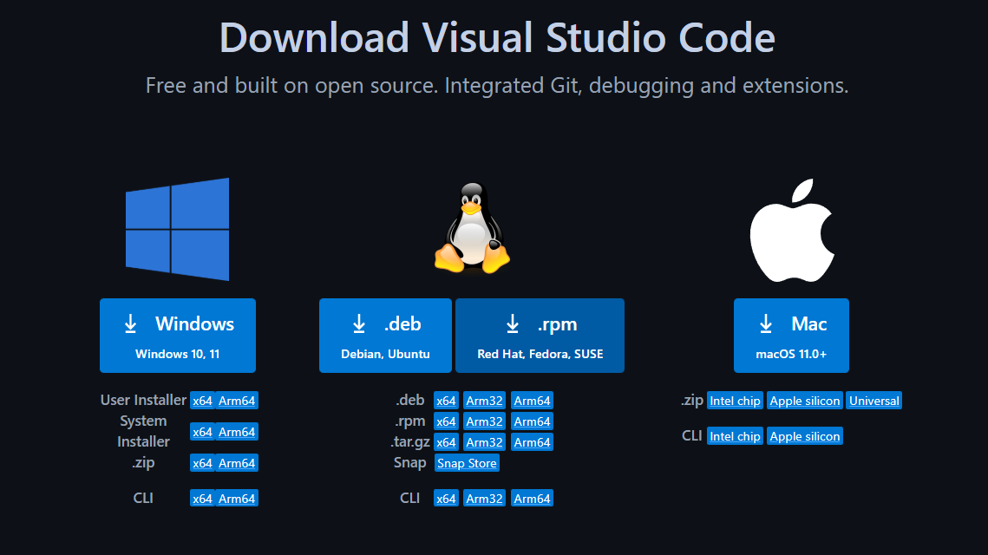

STEP-3: Run the file by Double-clicking on it
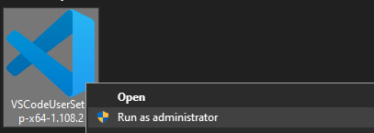

STEP-4
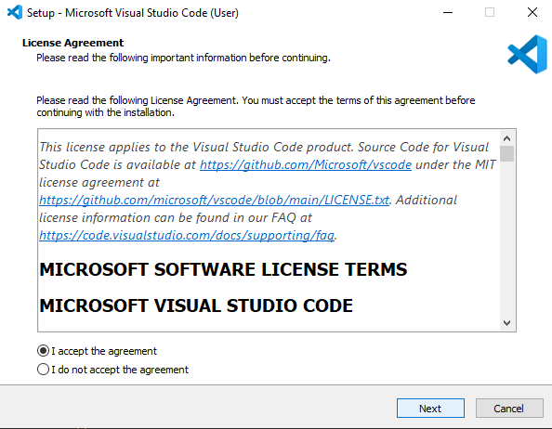

STEP-5:
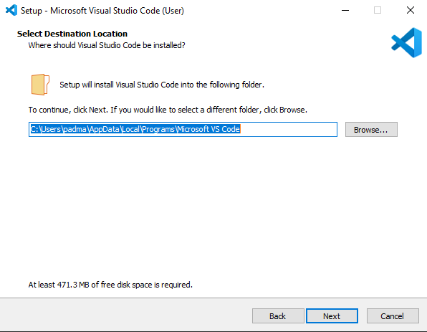

STEP-6: 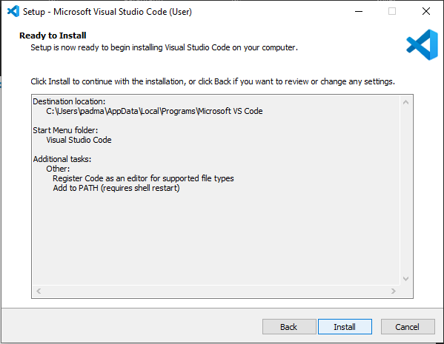

Step-7:
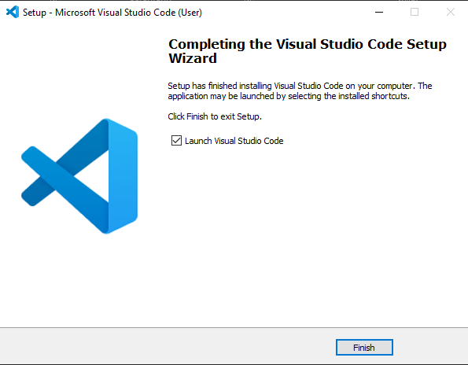
Now, It is Ready to use
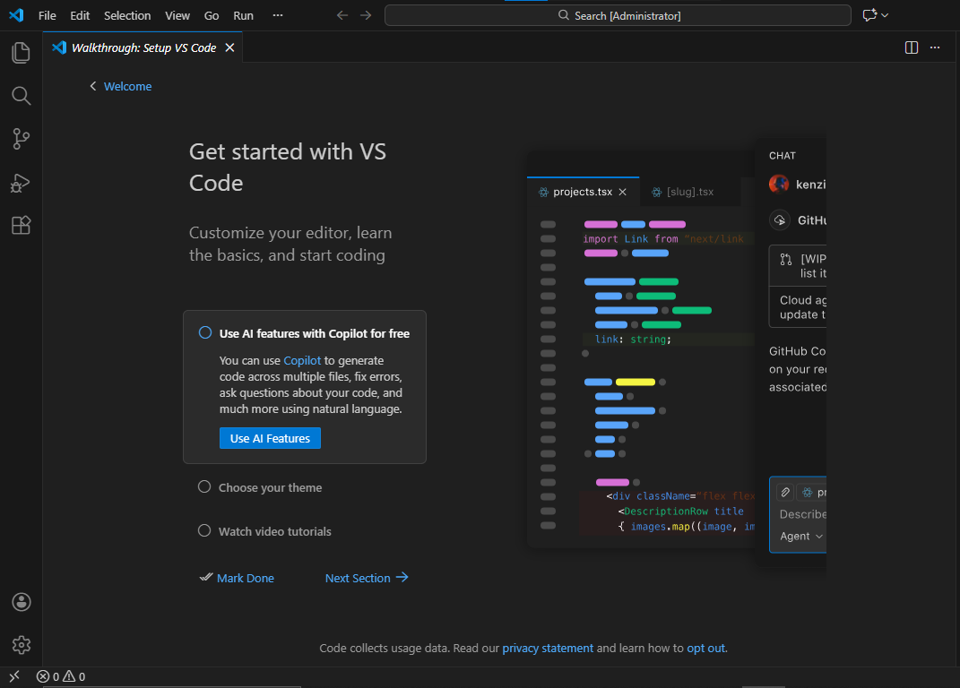

B. AIM: Create a Basic HTML Page
Program:
UID-AV.SC.U4CSE25223
<!DOCTYPE html>
<html>
<head>
<title>First Web Page</title>
</head>
<body>
<h1>Happy to learn HTML</h1>
<p>This is my first sample code</p>
</body>
</html>

OUTPUT:
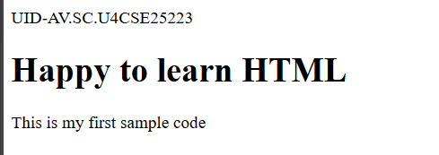

Explanation of the tags:
- HTML stands for Hyper Text Markup Language.
- It tells the web browser what to display and how to display it.
- <DOCTYPE HTML>: The <DOCTYPE html>element tells the browser, this is an HTML5 document.
- <html>: The <html> element is the root element of an HTML page.
- <head>: The <head> element contains meta information about the HTML page.
- <title>: The <title> element specifies a title for the HTML page.
- <body>: The <body>element contains all visible content like text, images, links, tables, etc.
- <h3>: The <h3> element defines a large heading of size in the scale 1 to 6.
- <p>: The <p> element defines a paragraph.

C. AIM: Basic HTML Tags

Program:
- <br> and style attribute in tags
<!DOCTYPE html>
<html>
<head>
<title>Student Details</title>
</head>
<body>
<h1 style="color:red">My Details</h1>
<p style="color:aquamarine">Name: Padmanabhuni Akhil <br> Roll No. AV.SC.U4CSE25223 <br>Section: CSE-C<br>University: Amrita</p>
<h2 style="color:greenyellow">Personal Details</h2>
<p style="color:brown">Name: Padmanabhuni Akhil <br> Roll No. AV.SC.U4CSE25223 <br>Section: CSE-C<br>University: Amrita</p>
</body>
</html>
Output:
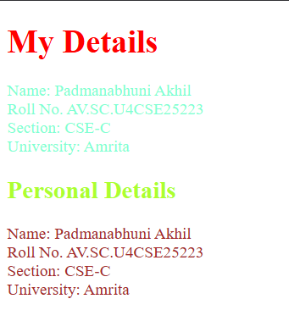

- URL Tags <a href= “link”>Text</a>
- Img Tags <img src= “source” alt= “Alternate Text” width= “” height= “”>
UID-AV.SC.U4CSE25223
<!DOCTYPE html>
<html>
<head>
<title>Links</title>
</head>
<body>
<h2>HTML Links</h2>
<p>HTML Links for some websites</p>
<h2>Amrita Vishwa Vidyapeetham</h2>
<p>Deemed to be a University</p>
<img src="Amrita.webp" alt="Amrita" width="104" height=""142>
<a href="https://www.amrita.edu/">Link</a>
<h2>SRM</h2>
<p>Deemed to be a University</p>
<img src="SRM.webp" alt="SRM" width="104" height=""142>
<a href="https://www.srmist.edu.in/">Link</a>
<h2>VIT</h2>
<p>Deemed to be a University</p>
<img src="VIT.webp" alt="VIT" width="104" height=""142>
<a href="https://vit.ac.in/">Link</a>
</body>
</html>
Output:
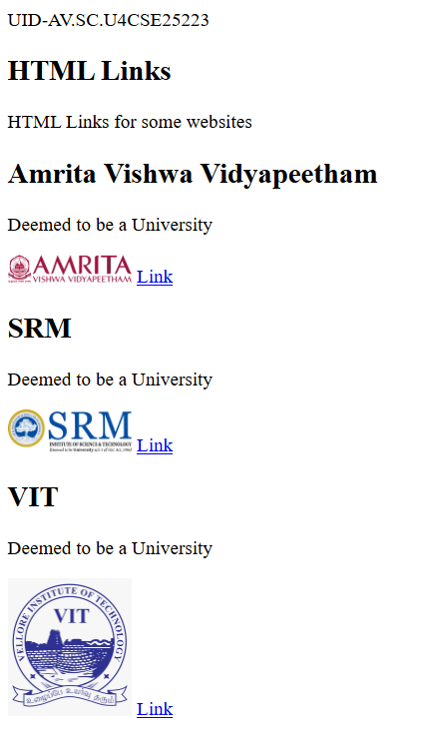
Explanation of the tags:

- <br>: The HTML <br> element defines a line break. it is an empty tag with no end tag.
- Style: The HTML style attribute is used to add styles to an element such as color, font, size and more.
- <img> : The <img> tag is a fundamental HTML element used to embed an image into a web page.
- <a> : The HTML <a> tag ,which stands for “anchor”, is used to define a hyperlink.

WEEK-2
2.
Code:
<!DOCTYPE html>
<html>
UID-CSE25223
<head>
<title>Life Quote</title>
</head>
<body background="Webpage.jpg" style="background-size: cover;">
<table width="98%" border="4" style="text-align: center;border-color: blueviolet;font-size: larger;font-family: 'Times New Roman', Times, serif;color: brown;">
<tr>
<th style="border-color: transparent;">Life Quotes</th>
</tr>
</table>
<pre style="text-align: center;color: blueviolet;font-size:large;"> You are the sum total of everything you've ever seen,

heard, eaten, smelled, been told, forgot—it's all there.

Everything influences each of us, and because of that I try

to make sure that my experiences are positive." —Maya Angelou</pre>
<table width="800" border="1" style="text-align: center;font-family: 'Times New Roman', Times, serif;background-image: url(Amaravati.jpg);background-repeat:no-repeat;background-size: cover;" align="center" cellspacing="10" cellpadding="10">
<caption style="background-color: azure;font-size: x-large;font-family: Arial, Helvetica, sans-serif;">AMRITA VISHWA VIDYAPEETHAM</caption>
<tr style="background-color: aqua;">
<th>S.No</th>
<th>Campus</th>
<th>Location</th>
<th>Cantact No</th>
<th colspan="2">Contact Person</th>
</tr>
<tr>
<th style="background-color: aquamarine;">1</th>
<th style="background-color: aquamarine;">Amaravati</th>
<th style="background-color: azure;">Kuragallu</th>
<th rowspan="2">+91-9807654321</th>
<th>Rajkumar</th>
<th>Batchu</th>
</tr>
<tr>
<th style="background-color: aquamarine;">2</th>
<th style="background-color: aquamarine;">Amritapuri</th>
<th style="background-color: azure;">Amrita Nagar</th>
<th colspan="2">Adithya Ram</th>
</tr>
<tr>
<th style="background-color: aquamarine;">3</th>
<th style="background-color: aquamarine;">Coimbatoore</th>
<th style="background-color: azure;">Ettimadai</th>
<th >+91-9087654321</th>
<th>AAshish</th>
<th style="background-color: rgb(129, 26, 220);">B</th>
</tr>
</table>
</body>
</html>
Output: 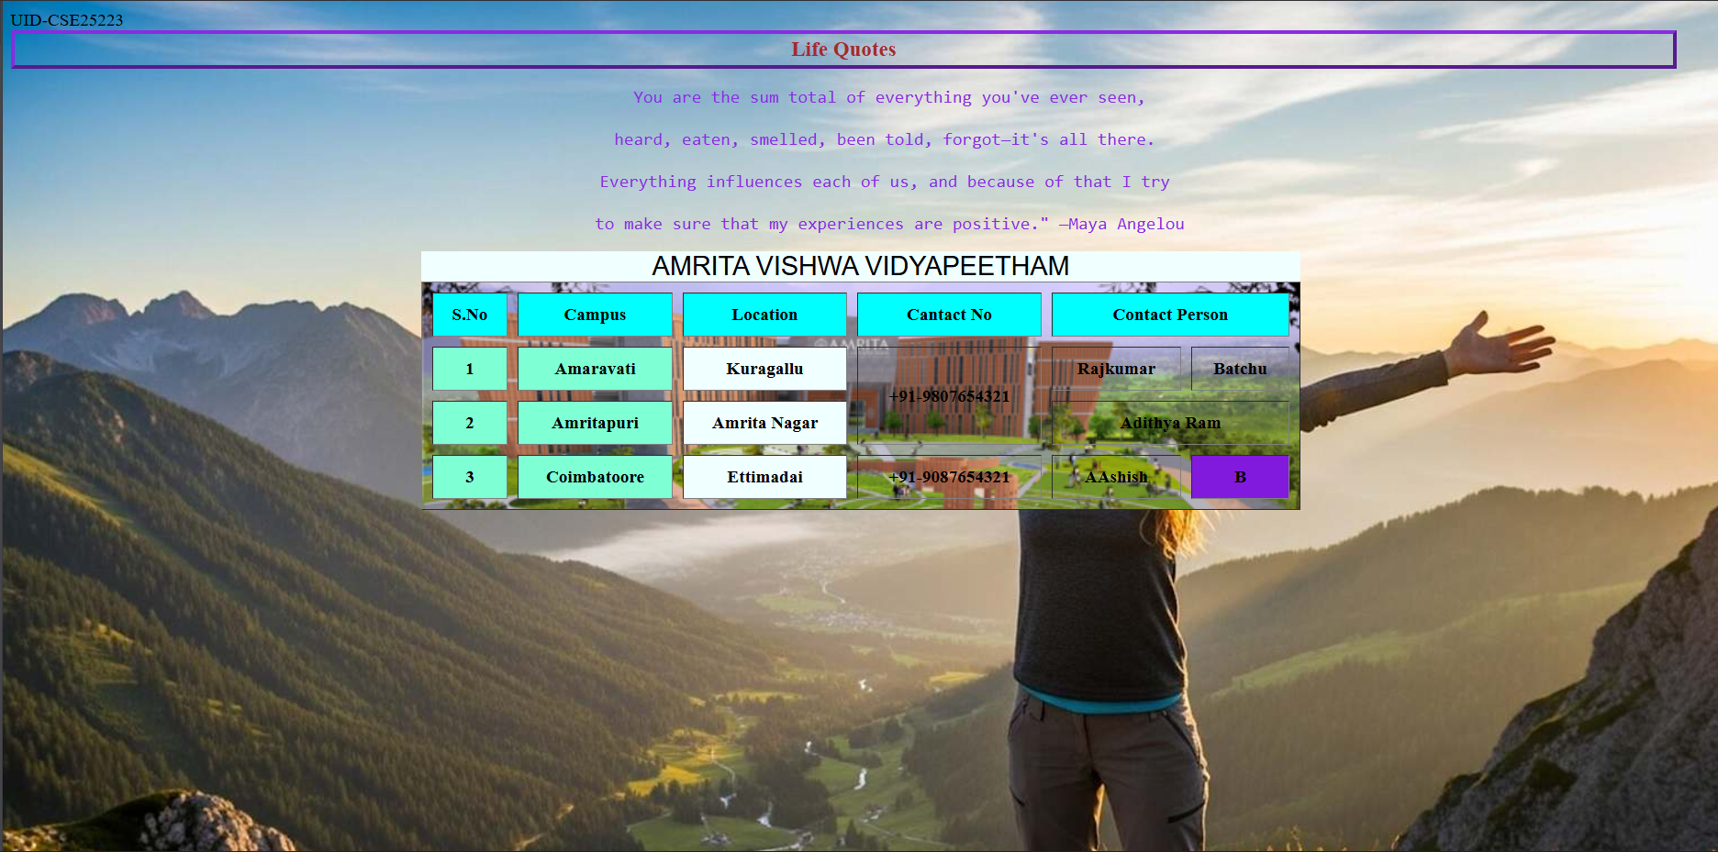

Explanation of the tags:

- <pre>: Shows text exactly as you type it, keeping all spaces and line breaks.
- <caption>: Adds a short title above a table.
- rowspan: Makes one table cell stretch down across several rows.
- colspan: Makes one table cell stretch across several columns.
- background: Sets a background image for an element (old way; now we usually use CSS).

WEEK-3
3.A. Aim: To create the class Timetable using HTML Elements.
Code:
<!DOCTYPE html>
<html>
<head>
<title>II CES-C Mater TT</title>
</head>
<body>
<table border="3" style="font-family: 'Courier New', Courier, monospace;text-align: center;" cellspacing="0" cellpadding="10">
<tr style="background-color: yellow;">
<th colspan="12">UID-CSE25223 Master Time Table</th>
</tr>
<tr>
<th rowspan="2">Time/ Day</th>
<th>Slot 1</th>
<th>Slot 2</th>
<th style="background-color: yellow;" rowspan="2">10:35-10:45</th>
<th>Slot 3</th>
<th>Slot 4</th>
<th>Slot 5</th>
<th style="background-color: yellow;" rowspan="2">1:15-2:10</th>
<th>Slot 6</th>
<th style="background-color: yellow;" rowspan="2">3:00-3:10</th>
<th>Slot 7</th>
<th>Slot 8</th>
</tr>
<tr>
<th>08:55-09:45</th>
<th>09:45-10:35</th>
<th>10:45-11:35</th>
<th>11:35-12:25</th>
<th>12:25-01:15</th>
<th>02:10-09:45</th>
<th>03:10-04:00</th>
<th>04:00-04:50</th>
</tr>
<tr>
<th>Monday</th>
<td colspan="2" style="background-color: aqua;">23MAT116 Discrete Mathematics_lab2</td>
<th rowspan="5" style="background-color: yellow;vertical-align:bottom;writing-mode:sideways-lr;">Short Break</th>
<td>23PHY115 Modern Physics</td>
<td>23CSE111 Object Oriented Programming</td>
<td>22ADM111 Glimpses of Glorious India</td>
<th rowspan="5" style="background-color: yellow;vertical-align:bottom;writing-mode:sideways-lr;">Lunch Break</th>
<td>22ADM111 Glimpses of Glorious India(P)</td>
<th rowspan="5" style="background-color: yellow;vertical-align:bottom;writing-mode:sideways-lr;">Short Break</th>
<td colspan="2">Library/Sports</td>
</tr>
<tr>
<th>Tuesday</th>
<td colspan="2" style="background-color: rgb(227, 84, 235);">23CSE113 User Interface Design LAB(BYOD)</td>
<td>23MAT117 Linear Algebra</td>
<td>23MAT116 Discrete Mathematics</td>
<td style="color: red;">COUNSELLING</td>
<td style="background-color: bisque;">23MEE115 Manufacturing Practice LAB</td>
<td colspan="2" style="background-color: bisque;">23MEE115 Manufacturing Practice LAB</td>
</tr>
<tr>
<th>Wednesday</th>
<td >23PHY115 Modern Physics</td>
<td>23CSE113 User Interface Design</td>
<td colspan="2" style="background-color: aquamarine;">23MAT117 Linear Algebra_LAB(BYOD)</td>
<td style="color: red;">COUNSELLING</td>
<td >Library</td>
<td>22ADM111vGlimpses of Glorious India</td>
<td>Library/Sports</td>
</tr>
<tr>
<th>Thursday</th>
<td >23CSE111 Object Oriented Programming</td>
<td>23MAT116 Discrete Mathematics</td>
<td colspan="2" style="background-color: blueviolet;">23CSE111Object Oriented Programming _Lab2</td>
<td >23MAT117 Linear Algebra</td>
<td >Library</td>
<td colspan="2">Library/Sports</td>
</tr>
<tr>
<th>Friday</th>
<td >23CSE111 Object Oriented Programming</td>
<td>23MAT116 Discrete Mathematics</td>
<td >23PHY115 Modern Physics</td>
<td >23PHY115 Modern Physics</td>
<td >23CSE113 User Interface Design</td>
<td >Library</td>
<td colspan="2">Library/Sports</td>
</tr>
</table>
<p><br><br><br><br></p>
<table border="3" style="font-family: 'Courier New', Courier, monospace;" cellspacing="0" cellpadding="10">
<tr>
<th>Course Code</th>
<th>Course Name</th>
<th>L-T-P</th>
<th>Credits</th>
<th>Faculty Name</th>
<th>Assisting Faculty</th>
</tr>
<tr>
<td>23MAT116</td>
<td>Discrete Mathematics</td>
<td>3-0-2</td>
<td>4</td>
<td>Dr.Srinivasa Rao Thota</td>
<td></td>
</tr>
<tr>
<td>23MAT117</td>
<td>Linear Algebra</td>
<td>3-0-2</td>
<td>4</td>
<td>Mr.Sapavat Bixapathi</td>
<td></td>
</tr>
<tr>
<td>23CSE111</td>
<td>Object Oriented Programming</td>
<td>3-0-2</td>
<td>4</td>
<td>Dr.Satya Rajendra Singh R</td>
<td>Dr.Balaji TK</td>
</tr>
<tr>
<td>23PHY115</td>
<td>Modern Physics</td>
<td>2-1-0</td>
<td>3</td>
<td>Dr.Soumya</td>
<td></td>
</tr>
<tr>
<td>23CSE113</td>
<td>User Interface Design</td>
<td>2-0-2</td>
<td>3</td>
<td>Dr.Rajkumar Batchu</td>
<td>Mr.Barge Bharadwaj</td>
</tr>
<tr>
<td>23MEE115</td>
<td>Manufacturing Practice</td>
<td>0-0-3</td>
<td>1</td>
<td>Dr.Sathies S.</td>
<td></td>
</tr>
<tr>
<td>22ADM111</td>
<td>Glimpses of Glorius India</td>
<td>2-0-1</td>
<td>2</td>
<td>Dr.Siva Panuganti</td>
<td></td>
</tr>
<tr>
<td></td>
<td>Total(15L+1Tut+12P=28 hrs)</td>
<td>15-1-12</td>
<td>21</td>
<td></td>
<td></td>
</tr>
</table>
</body>
</html>

Output:
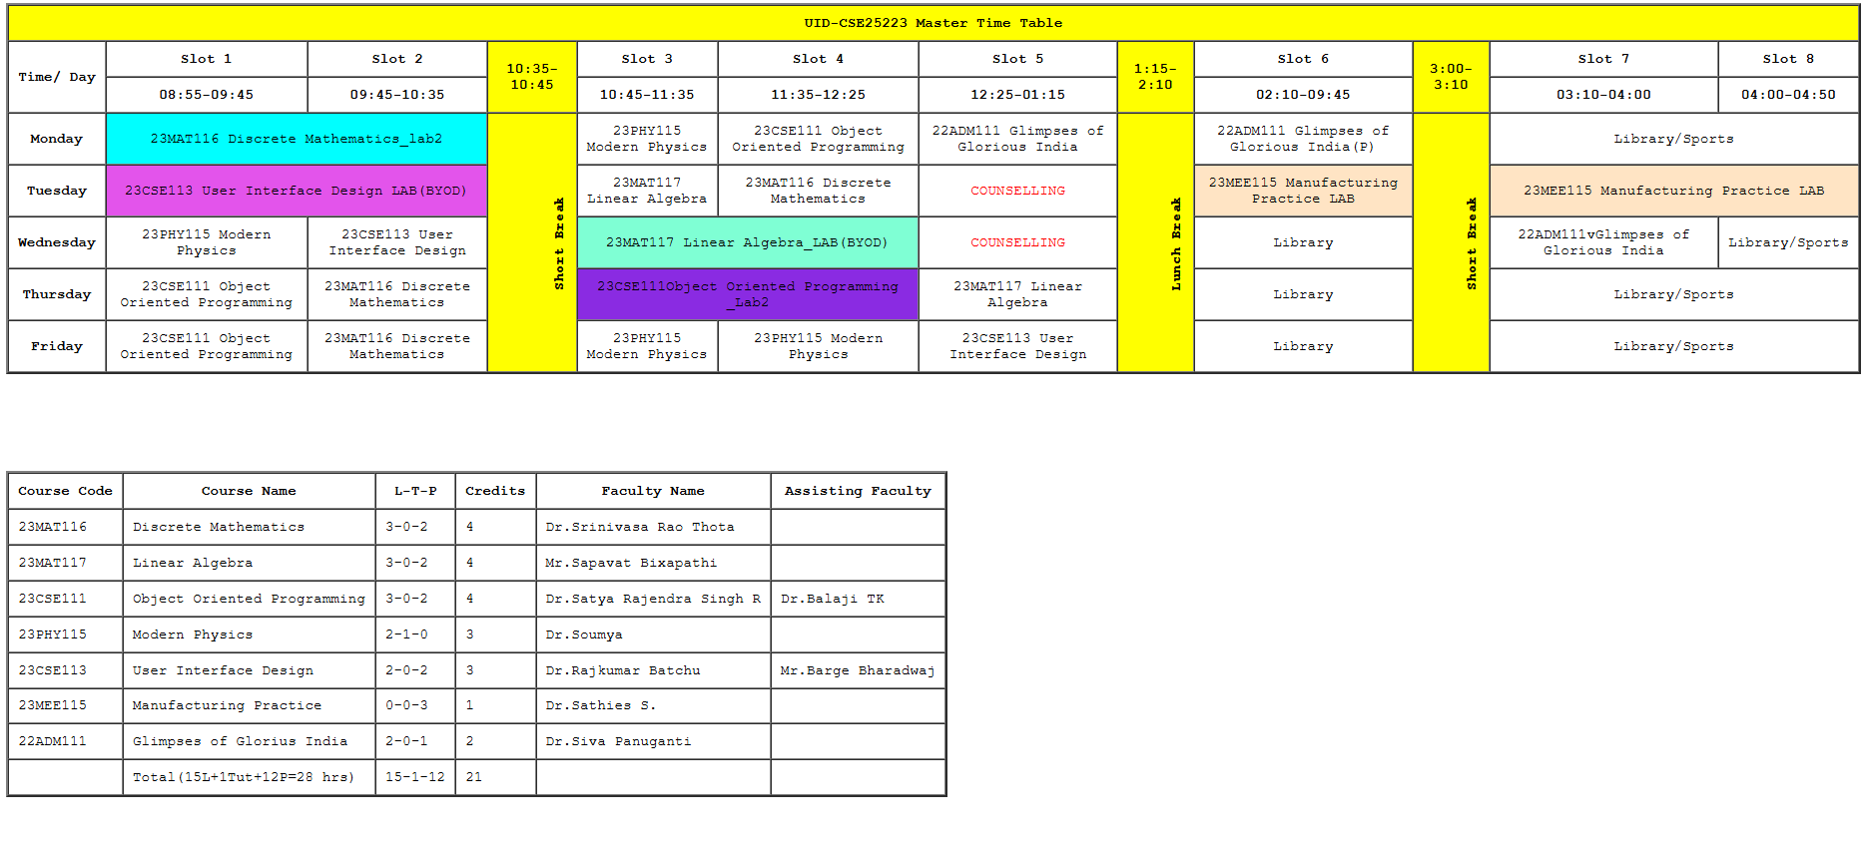

B. Aim: To Create an HTML Webpage displaying Syllabus of all the subjects with the timetable.
Code:
<!DOCTYPE html>
<html>
UID-CSE25223
<body>
<h1>Syllabus</h1>
<h2>Discrete Mathematics</h2>
<img src="Discrete.png" alt="Discrete Mathematics">
<h2>Linear Algebra</h2>
<img src="Linear.png" alt="Linear Algebra">
<h2>Object Oriented Programming</h2>
<img src="Java.png" alt="Object Oriented Programming">
<h2>Modern Physics</h2>
<img src="Modern.png" alt="Modern Physics">
<h2>Manufacturing Practice Lab</h2>
<img src="Manufacturing.png" alt="Manufacturing Practice Lab">
<h2>User Interface Design</h2>
<img src="UID.png" alt="User Interface Design">
<h2>Glimpses of Glorius India</h2>
<img src="Glimpses.png" alt="Glimpses of Glorius India">
<table border="3" style="font-family: 'Courier New', Courier, monospace;text-align: center;" cellspacing="0" cellpadding="10">
<tr style="background-color: yellow;">
<th colspan="12">UID-CSE25223 Master Time Table</th>
</tr>
<tr>
<th rowspan="2">Time/ Day</th>
<th>Slot 1</th>
<th>Slot 2</th>
<th style="background-color: yellow;" rowspan="2">10:35-10:45</th>
<th>Slot 3</th>
<th>Slot 4</th>
<th>Slot 5</th>
<th style="background-color: yellow;" rowspan="2">1:15-2:10</th>
<th>Slot 6</th>
<th style="background-color: yellow;" rowspan="2">3:00-3:10</th>
<th>Slot 7</th>
<th>Slot 8</th>
</tr>
<tr>
<th>08:55-09:45</th>
<th>09:45-10:35</th>
<th>10:45-11:35</th>
<th>11:35-12:25</th>
<th>12:25-01:15</th>
<th>02:10-09:45</th>
<th>03:10-04:00</th>
<th>04:00-04:50</th>
</tr>
<tr>
<th>Monday</th>
<td colspan="2" style="background-color: aqua;">23MAT116 Discrete Mathematics_lab2</td>
<th rowspan="5" style="background-color: yellow;vertical-align:bottom;writing-mode:sideways-lr;">Short Break</th>
<td>23PHY115 Modern Physics</td>
<td>23CSE111 Object Oriented Programming</td>
<td>22ADM111 Glimpses of Glorious India</td>
<th rowspan="5" style="background-color: yellow;vertical-align:bottom;writing-mode:sideways-lr;">Lunch Break</th>
<td>22ADM111 Glimpses of Glorious India(P)</td>
<th rowspan="5" style="background-color: yellow;vertical-align:bottom;writing-mode:sideways-lr;">Short Break</th>
<td colspan="2">Library/Sports</td>
</tr>
<tr>
<th>Tuesday</th>
<td colspan="2" style="background-color: rgb(227, 84, 235);">23CSE113 User Interface Design LAB(BYOD)</td>
<td>23MAT117 Linear Algebra</td>
<td>23MAT116 Discrete Mathematics</td>
<td style="color: red;">COUNSELLING</td>
<td style="background-color: bisque;">23MEE115 Manufacturing Practice LAB</td>
<td colspan="2" style="background-color: bisque;">23MEE115 Manufacturing Practice LAB</td>
</tr>
<tr>
<th>Wednesday</th>
<td >23PHY115 Modern Physics</td>
<td>23CSE113 User Interface Design</td>
<td colspan="2" style="background-color: aquamarine;">23MAT117 Linear Algebra_LAB(BYOD)</td>
<td style="color: red;">COUNSELLING</td>
<td >Library</td>
<td>22ADM111vGlimpses of Glorious India</td>
<td>Library/Sports</td>
</tr>
<tr>
<th>Thursday</th>
<td >23CSE111 Object Oriented Programming</td>
<td>23MAT116 Discrete Mathematics</td>
<td colspan="2" style="background-color: blueviolet;">23CSE111Object Oriented Programming _Lab2</td>
<td >23MAT117 Linear Algebra</td>
<td >Library</td>
<td colspan="2">Library/Sports</td>
</tr>
<tr>
<th>Friday</th>
<td >23CSE111 Object Oriented Programming</td>
<td>23MAT116 Discrete Mathematics</td>
<td >23PHY115 Modern Physics</td>
<td >23PHY115 Modern Physics</td>
<td >23CSE113 User Interface Design</td>
<td >Library</td>
<td colspan="2">Library/Sports</td>
</tr>
</table>
<p><br><br><br><br></p>
<table border="3" style="font-family: 'Courier New', Courier, monospace;" cellspacing="0" cellpadding="10">
<tr>
<th>Course Code</th>
<th>Course Name</th>
<th>L-T-P</th>
<th>Credits</th>
<th>Faculty Name</th>
<th>Assisting Faculty</th>
</tr>
<tr>
<td>23MAT116</td>
<td>Discrete Mathematics</td>
<td>3-0-2</td>
<td>4</td>
<td>Dr.Srinivasa Rao Thota</td>
<td></td>
</tr>
<tr>
<td>23MAT117</td>
<td>Linear Algebra</td>
<td>3-0-2</td>
<td>4</td>
<td>Mr.Sapavat Bixapathi</td>
<td></td>
</tr>
<tr>
<td>23CSE111</td>
<td>Object Oriented Programming</td>
<td>3-0-2</td>
<td>4</td>
<td>Dr.Satya Rajendra Singh R</td>
<td>Dr.Balaji TK</td>
</tr>
<tr>
<td>23PHY115</td>
<td>Modern Physics</td>
<td>2-1-0</td>
<td>3</td>
<td>Dr.Soumya</td>
<td></td>
</tr>
<tr>
<td>23CSE113</td>
<td>User Interface Design</td>
<td>2-0-2</td>
<td>3</td>
<td>Dr.Rajkumar Batchu</td>
<td>Mr.Barge Bharadwaj</td>
</tr>
<tr>
<td>23MEE115</td>
<td>Manufacturing Practice</td>
<td>0-0-3</td>
<td>1</td>
<td>Dr.Sathies S.</td>
<td></td>
</tr>
<tr>
<td>22ADM111</td>
<td>Glimpses of Glorius India</td>
<td>2-0-1</td>
<td>2</td>
<td>Dr. Siva Panuganti</td>
<td></td>
</tr>
<tr>
<td></td>
<td>Total(15L+1Tut+12P=28 hrs)</td>
<td>15-1-12</td>
<td>21</td>
<td></td>
<td></td>
</tr>
</table>
</body>
</html>

Output:
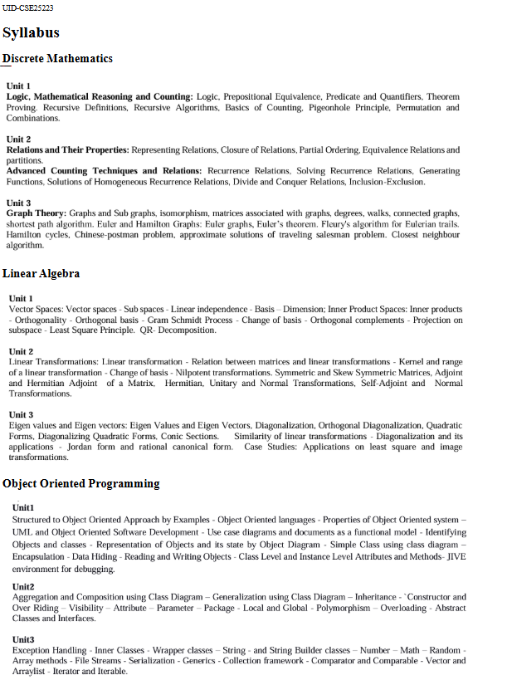
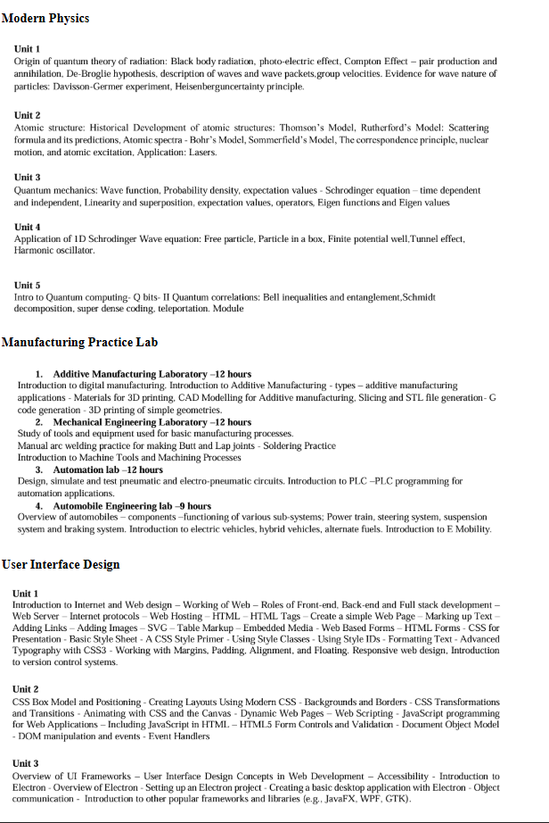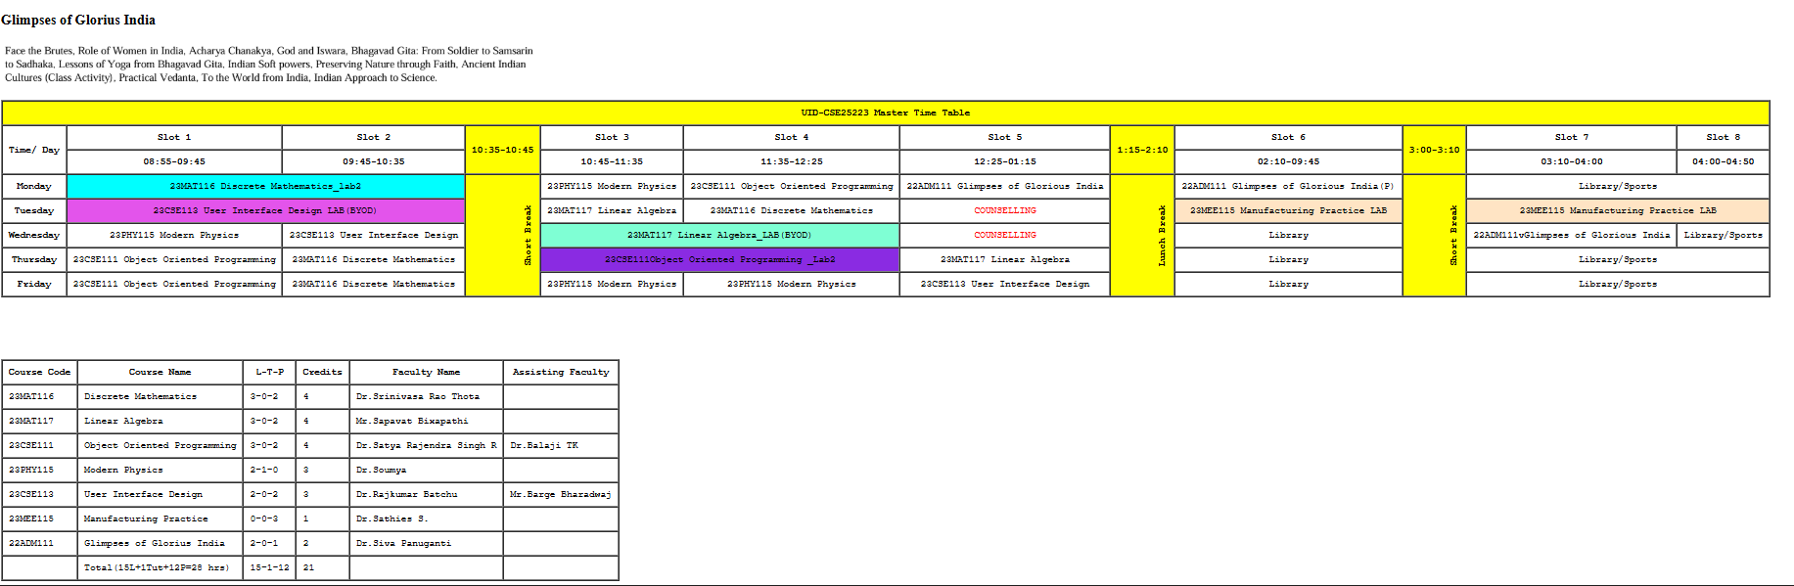
Explanation of the Tags:
- rowspan - rowspan=n" – Merges n cells vertically
- colspan - colspan="n" – Merges n cells horizontally
- cellspacing - cellspacing="m" - Space between table cells
- cellpadding - cellpadding="m" - Padding inside table cells
- background-color - background-color: aqua; - Cell background color to aqua
- color - color: red; - Text color for counselling
- vertical-align - vertical-align: bottom; - Bottom cell alignment
- writing-mode - writing-mode: sideways-lr; - Rotates break labels
- font-family - font-family: 'Courier New', monospace; - Monospace font
- text-align - text-align: center; - Center the table content

WEEK-4
4.A. Aim: To collect student details through a structured HTML form with proper labels and table layout.
Code:
<!DOCTYPE html>
<html>
UID-CSE25223
<body>
<p>P.Akhil</p>
<h1 align="center">HTML Forms</h1>
<table border="1" cellpadding="10" cellspacing="0" align="center">
<tr>
<th>Full Name</th>
<td><input type="text" name="fname"></td>
</tr>
<tr>
<th>Email</th>
<td><input type="email" name="email"></td>
</tr>
<tr>
<th>Phone Number</th>
<td><input type="tel" name="phone"></td>
</tr>
<tr>
<th>Gender</th>
<td>
<input type="radio" name="gender" value="male"> Male
<input type="radio" name="gender" value="female"> Female
<input type="radio" name="gender" value="other"> Other
</td>
</tr>
<tr>
<th>Course Applying for?</th>
<td>
<select name="course">
<option value="bt">BTech</option>
<option value="bba">BBA</option>
<option value="mbbs">MBBS</option>
</select>
</td>
</tr>
<tr>
<th>Hobbies</th>
<td>
<input type="checkbox" name="hobby" value="sports"> Sports
<input type="checkbox" name="hobby" value="music"> Music
<input type="checkbox" name="hobby" value="reading"> Reading
</td>
</tr>
<tr>
<th>Date of Birth</th>
<td><input type="date" name="dob"></td>
</tr>
<tr>
<th>Upload Certificate</th>
<td><input type="file" name="certi"></td>
</tr>
<tr>
<th>Address</th>
<td><textarea name="address" rows="4" cols="50"></textarea></td>
</tr>
<tr>
<td colspan="2" align="center"><input type="submit" value="Submit"><input type="reset" value="Reset"></td>
</tr>
</table>
</body>

Output: 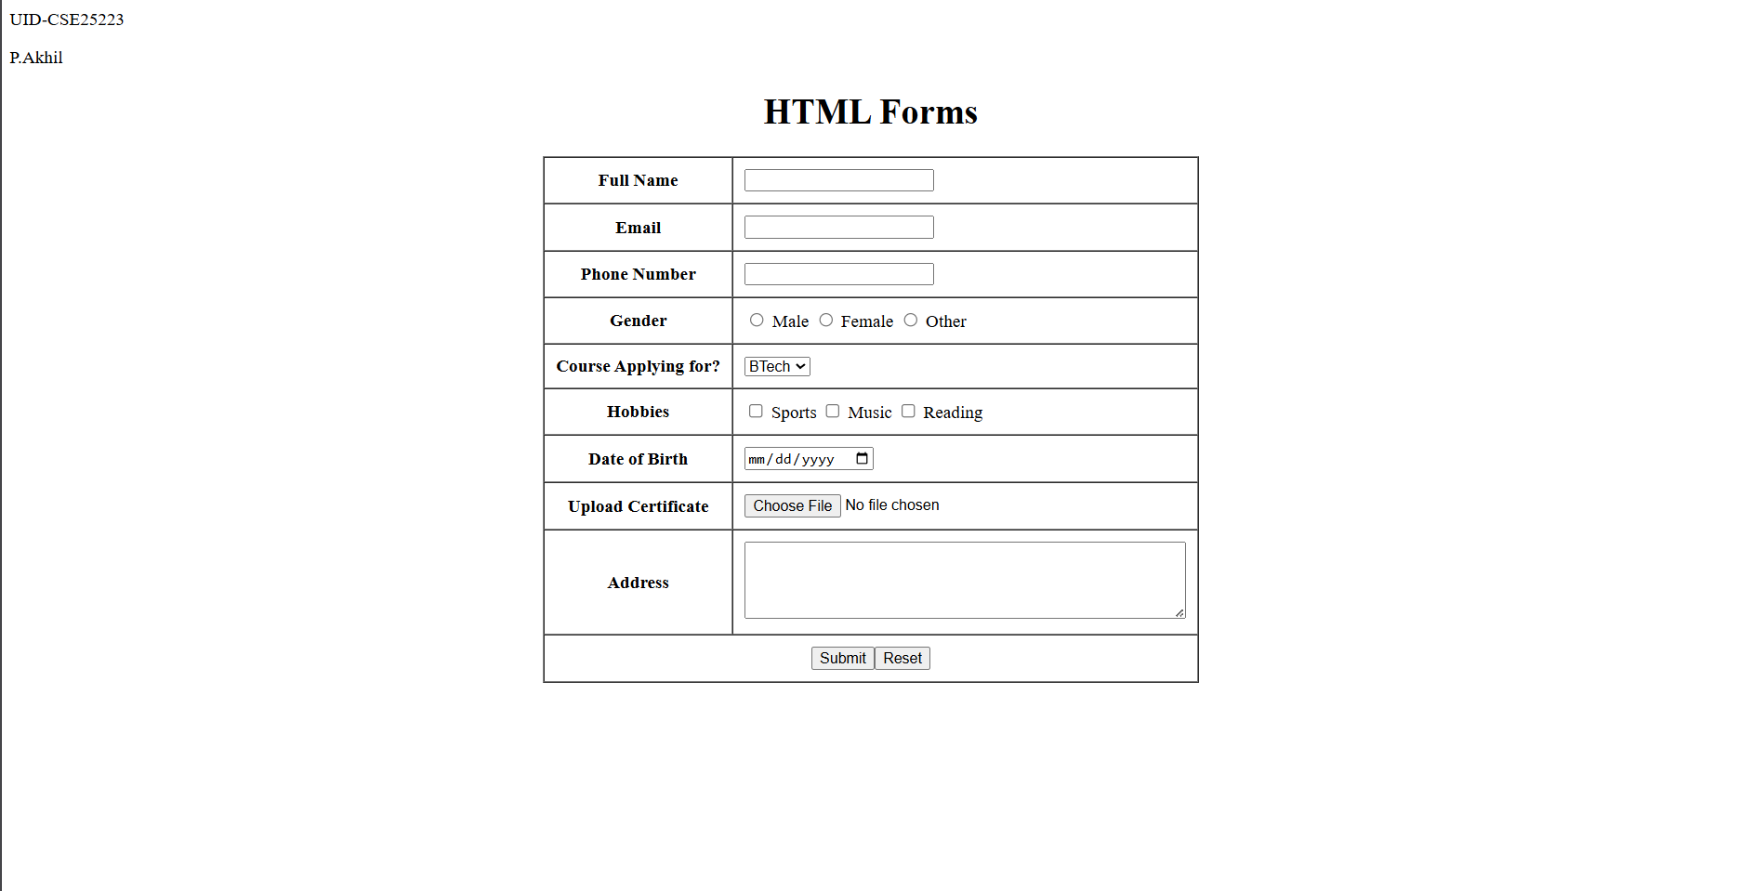

Explanation of the tags:

- <input type="text">: Creates a single-line text box for basic input like names.
- <input type="email">: Makes a text field that expects and validates email format.
- <input type="tel">: Input field designed for telephone numbers.
- <input type="radio">: Lets users pick one option from a group (like gender).
- <select>: Creates a dropdown menu with predefined choices.
- <option>: Individual items inside a dropdown/select menu.
- <input type="checkbox">: Lets users select multiple options (like hobbies).
- <input type="date">: Opens a calendar picker for selecting dates.
- <input type="file">: Button to upload and select files from computer.
- <textarea>: Multi-line text input box for longer content like addresses.
- <input type="submit">: Button that sends form data when clicked.
- <input type="reset">: Button that clears all form fields.
- colspan="2": Makes one cell stretch across two columns in the table.

4.B. Aim: To create a webpage showing Login and Registration forms side-by-side using iframes for easy embedding.
Code:
Login.html
<!DOCTYPE html>
<html>
<head>
<title>Login Form</title>
</head>
<body style="background-color: antiquewhite; font-family: Arial; text-align: center;">

<div class="box">
<h3>User Login</h3>

<form >
<table style="text-align: center;" align="center" cellpadding="10" cellspacing="0" border="1">
<tr>
<td>Username:</td>
<td><input type="text" name="username"></td>
</tr>
<tr></tr>
<td>Password:</td>
<td><input type="password" name="password"></td>
</tr>
<tr>
<td colspan="2" align="center"><button type="submit">Login</button></td>
</tr>
</table>
</form>
</div>

</body>
</html>

Register.html
<!DOCTYPE html>
<html>
<head>
<title>Registration Form</title>
</head>
<body style="background-color: antiquewhite; font-family: Arial; text-align: center;">

<div class="box">
<h3>User Registration</h3>

<form>
<table style="text-align: center;" align="center" cellpadding="10" cellspacing="0" border="1">
<tr>
<th>Field</th>
<th>Input</th>
</tr>
<tr>
<td>Full Name:</td>
<td><input type="text" name="fullname"></td>
</tr>
<tr>
<td>Email:</td>
<td><input type="email" name="email"></td>
</tr>
<tr>
<td>Phone Number:</td>
<td><input type="tel" name="phone"></td>
</tr>
<tr>
<td>Password:</td>
<td><input type="password" name="password"></td>
</tr>
<tr>
<td colspan="2" align="center"><button type="submit">Register</button> <button type="reset">Reset</button></td>
</tr>
</table>
</form>
</div>

</body>
</html>

Main:
<!DOCTYPE html>
<html>
UID-CSE25223
<head>
<title>Two Forms Using Iframes</title>
<style>
body {
font-family: Arial, sans-serif;
background-color: #f2f2f2;
text-align: center;
}

h2 {
margin-top: 20px;
}

.container {
display: flex;
justify-content: center;
gap: 40px;
margin-top: 30px;
}

iframe {
width: 350px;
height: 400px;
border: 2px solid #555;
background-color: #fff;
}
</style>
</head>
<body>

<h2>Two Forms Displayed Using Iframes</h2>

<div class="container">
<iframe src="login.html" name="loginFrame"></iframe>
<iframe src="register.html" name="registerFrame"></iframe>
</div>

</body>
</html>

Output:
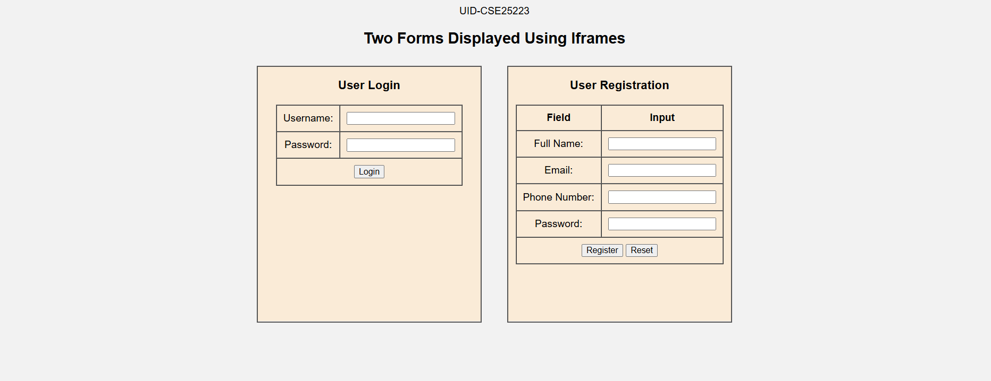
Explanation of the tags:

- <iframe>: Embeds another HTML page (like login.html) inside the current webpage as a frame.
- <div class="box">: Groups content together and applies CSS styling through the class name.
- <button type="submit">: Styled clickable button that submits form data (looks better than basic input).
- <th>: Makes table headers bold and centered (used in registration form headers).
- style="": Inline CSS that styles elements directly (background-color, font-family, text-align).
- .container: CSS class using flex layout to position two iframes side by side.
- display: flex: CSS property that arranges items horizontally in a row.
- justify-content: center: CSS centers the flex items (iframes) horizontally.
- gap: 40px: CSS adds space between the two side-by-side iframes.

WEEK-5
5.A. Aim: To create a card layout using <div> tag consider three cards and a button using HTML and CSS
Code:
UID-AV.SC.U4CSE25223
<!DOCTYPE html>
<html>
<head>
<title>Indian Freedom Fighters</title>
<style>
body {
font-family: Arial;
background: #0f172a;
text-align: center;
}
h1 {
background: #3fd9a5;
padding: 20px;
color: white;
}
.container {
display: flex;
flex-wrap: wrap;
justify-content: center;
gap: 20px;
padding: 30px;
}
.card {
background: white;
color: black;
width: 260px;
padding: 20px;
border-radius: 12px;
box-shadow: 0 5px 15px gray;
}
.hero-img {
width: 150px;
height: 200px;
object-fit: cover;
border-radius: 8px;
}
button {
padding: 8px 16px;
border: none;
background: #3fd9a5;
color: white;
border-radius: 6px;
cursor: pointer;
}
button:hover {
background: black;
}
</style>
</head>
<body>
<h1>Indian Freedom Fighters</h1>

<div class="container">
<div class="card">
<img class="hero-img" src="bhagat.webp" alt="Bhagat Singh">
<h3>Bhagat Singh</h3>
<p>Revolutionary Leader</p>
<button>Know More</button>
</div>

<div class="card">
<img class="hero-img" src="Subhash.webp" alt="Subhas Chandra Bose">
<h3>Subhas Chandra Bose</h3>
<p>Netaji</p>
<button>Know More</button>
</div>

<div class="card">
<img class="hero-img" src="sardar.webp" alt="Sardar Vallabhbhai Patel">
<h3>Sardar Vallabhbhai Patel</h3>
<p>Iron Man of India</p>
<button>Know More</button>
</div>
</div>
</body>
</html>

Output:
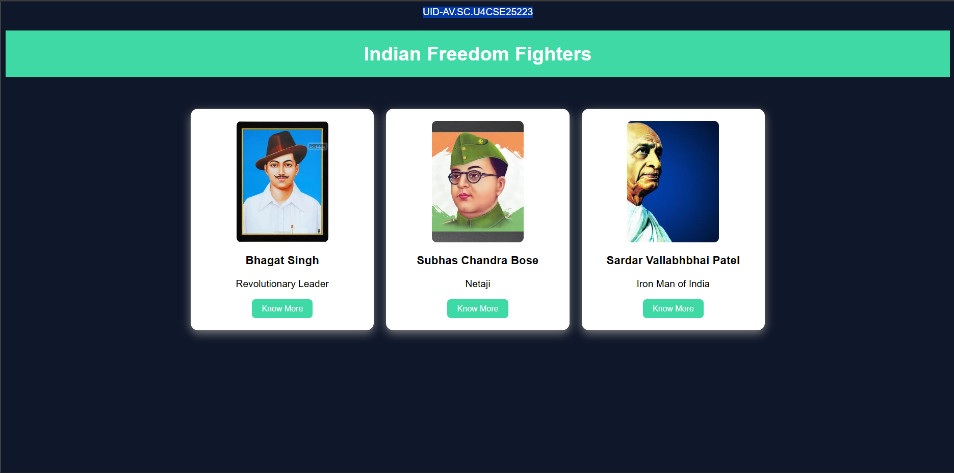

Explanation of the tags:
- .container { ... }: CSS class that uses flexbox to position cards side by side with spacing.
- display: flex: Lays out card items in a flexible row/line.
- flex-wrap: wrap: Allows cards to move to next line on smaller screens.
- justify-content: center: Centers all cards horizontally in the container.
- gap: 20px: Adds consistent space between each card.
- .card { ... }: Styles individual card boxes with size, shadow, rounded corners.
- border-radius: 12px: Rounds card corners for modern look.
- box-shadow: 0 5px 15px gray: Creates drop shadow to make cards appear lifted.
- .hero-img { ... }: Styles images inside cards with fixed dimensions.
- object-fit: cover: Crops images to fill container without distortion.
- button:hover { ... }: Changes button appearance when mouse hovers over it.

5.B. Aim: Navigation using iframe (mini website) upon clicking each buttons the details about that button should be display on the same page
Code:
Main File:
UID-AV.SC.U4CSE25223
<!DOCTYPE html>
<html>
<head>
<title>Bhagat Singh</title>
<style>
body{margin:0;font-family:Arial;background-color: gray;}
.menu{
background:#b91c1c;
padding:15px;
text-align:center;
}
.menu a{
color:white;
margin:0 15px;
text-decoration:none;
background:black;
padding:8px 12px;
}
iframe{
width:100%;
height:400px;
border:none;
}
</style>
</head>
<body>
<h1 style="text-align:center;background:#b91c1c;color:white;padding:20px;">
Bhagat Singh
</h1>

<div class="menu">
<a href="strengths.html" target="frame">Ideals & Weaknesses</a>
<a href="personal.html" target="frame">Personal Info</a>
<a href="contribution.html" target="frame">Contributions</a>
</div>

<iframe name="frame"></iframe>
</body>
</html>

strengths.html:
<!DOCTYPE html>
<html>
<head>
<style>
body{font-family:Arial;text-align:center;}
.box{
border:2px solid black;
padding:20px;
display:inline-block;
}
h2{color:#b91c1c;}
</style>
</head>
<body>
<div class="box">
<h2>Personal Information</h2>
<p>Name: Bhagat Singh</p>
<p>Born: 28 September 1907, Punjab</p>
<p>Movement: Indian Independence Movement</p>
<img src="bhagat2.webp"
alt="Bhagat Singh Portrait"
style="width:200px;margin-top:20px;">
</div>
</body>
</html>

personal.html:
<!DOCTYPE html>
<html>
<head>
<style>
body{font-family:Arial;text-align:center;}
.box{
border:2px solid black;
padding:20px;
display:inline-block;
}
h2{color:#b91c1c;}
</style>
</head>
<body>
<div class="box">
<h2>Personal Information</h2>
<p>Name: Bhagat Singh</p>
<p>Born: 28 September 1907, Punjab</p>
<p>Movement: Indian Independence Movement</p>
<img src="bhagat2.webp"
alt="Bhagat Singh Portrait"
style="width:200px;margin-top:20px;">
</div>
</body>
</html>

contribution.html:
<!DOCTYPE html>
<html>
<head>
<style>
body{font-family:Arial;text-align:center;}
.box{
border:2px solid black;
padding:20px;
display:inline-block;
}
h2{color:#8edc7b;}
</style>
</head>
<body>
<div class="box">
<h2>Contributions</h2>
<p>Inspired youth to join the freedom struggle.</p>
<p>Protested against British rule through revolutionary activities.</p>
<p>Became a symbol of sacrifice after his martyrdom.</p>
<img src="bhagat3.webp"
alt="Bhagat Singh"
style="width:200px;margin-top:20px;">
</div>
</body>
</html>

Output:
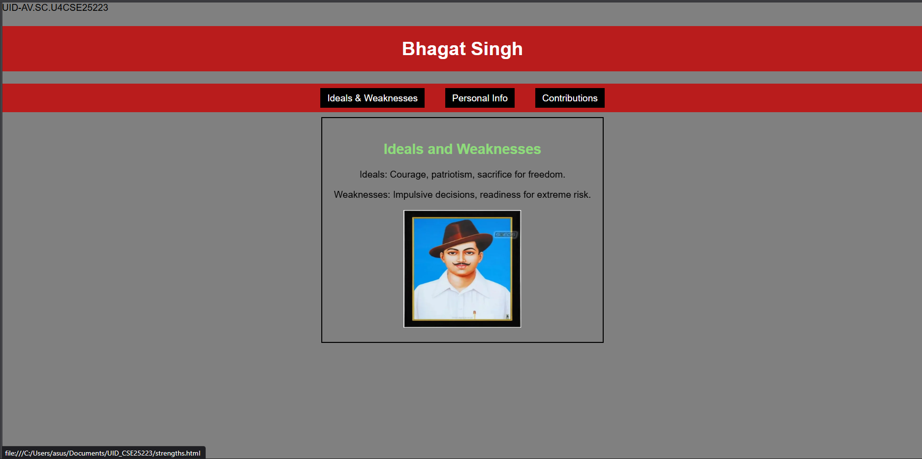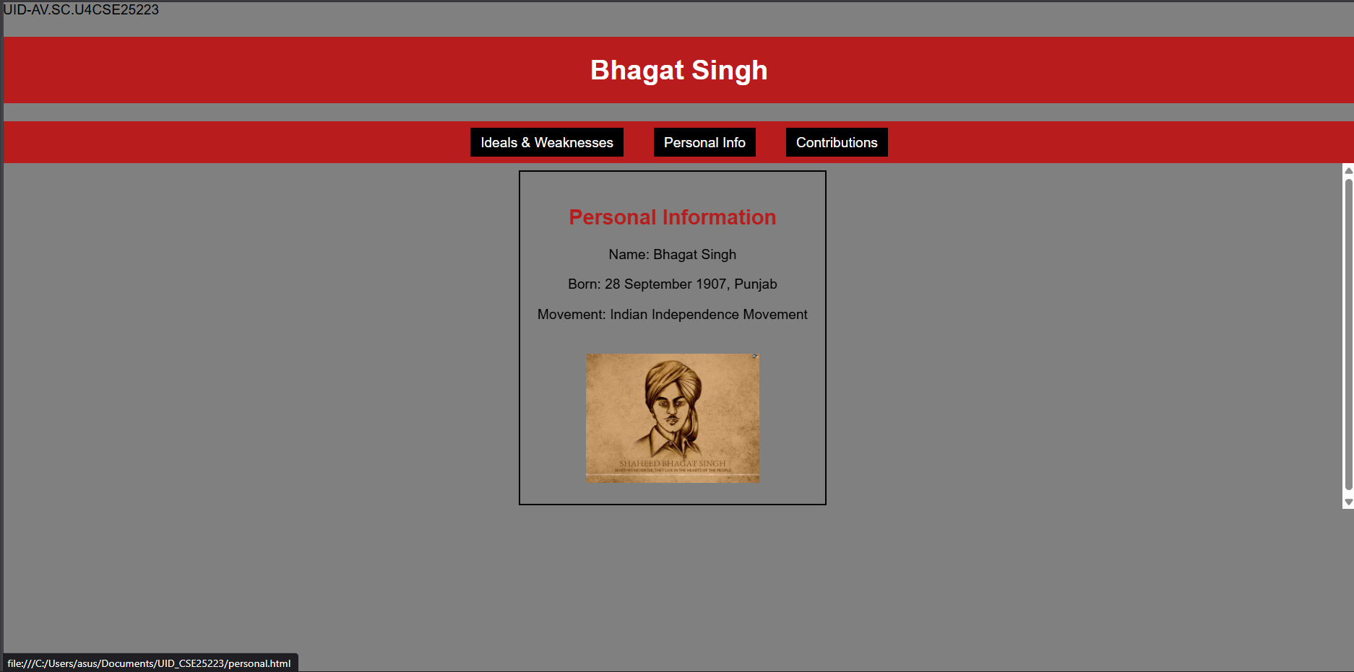
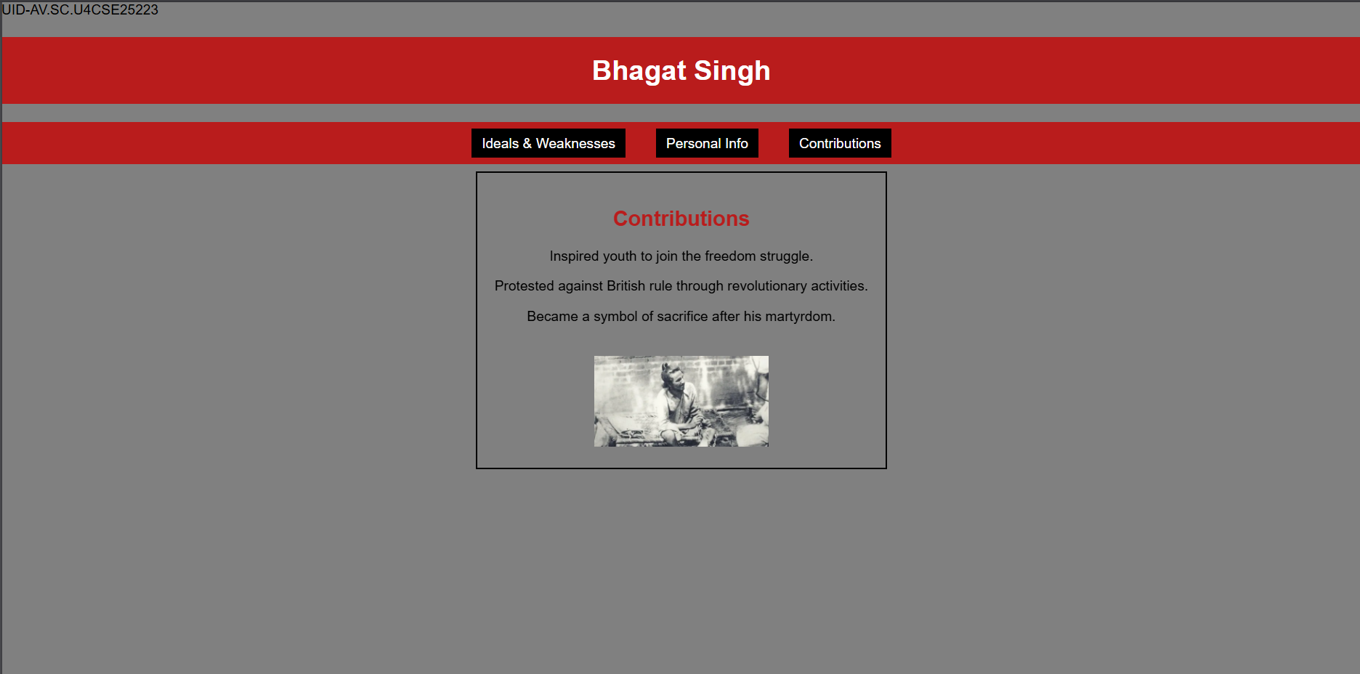
Explanation of the tags:
- iframe { ... }: Styles embedded frame (full width, 400px height, no border).
- target="frame": Loads linked pages inside specific iframe by name.
- name="frame": Names iframe so menu links can target it.
- .menu a { ... }: Styles navigation links (spacing, no underline, black background).
- margin:0 15px: Horizontal spacing between menu links.
- text-decoration:none: Removes underline from clickable links.
- .box { ... }: Styles sub-page content box (border, padding, inline-block).
- display:inline-block: Box fits content width, sits in line.

Main File:
UID-AV.SC.U4CSE25223
<!DOCTYPE html>
<html>
<head>
<title>Amrita Vishwa Vidyapeetham</title>
<style>
body {
margin: 0;
font-family: Arial;
background: rgb(50, 50, 100);
}
header {
background: #ff4444;
color: #fff;
text-align: center;
padding: 20px;
font-size: 36px;
}
nav {
background: #0066cc;
text-align: center;
padding: 10px;
}
nav a {
color: #ffff00;
margin: 12px;
text-decoration: none;
font-weight: bold;
padding: 5px;
}
nav a:hover {
background: #fff;
color: #0066cc;
border-radius: 5px;
}
main {
display: flex;
padding: 20px;
}
.login {
width: 350px;
background: #ffaa00;
padding: 15px;
border-radius: 10px;
color: white;
}
.login input[type="email"],
.login input[type="password"] {
width: 90%;
padding: 6px;
margin: 6px 0;
}
.remember {
display: flex;
align-items: center;
gap: 6px;
margin: 8px 0;
}
iframe {
flex: 1;
margin-left: 20px;
height: 520px;
border: none;
background: #aaffff;
border-radius: 10px;
}
</style>
</head>
<body>
<header>AMRITA VISHWA VIDHYAPEETAM</header>

<nav>
<a href="amaravati.html" target="campus">AMARAVATI</a>
<a href="amritapuri.html" target="campus">AMRITAPURI</a>
<a href="bengaluru.html" target="campus">BENGALURU</a>
<a href="chennai.html" target="campus">CHENNAI</a>
<a href="coimbatore.html" target="campus">COIMBATORE</a>
<a href="faridabad.html" target="campus">FARIDABAD</a>
<a href="kochi.html" target="campus">KOCHI</a>
<a href="mysuru.html" target="campus">MYSURU</a>
</nav>

<main>
<div class="login">
<h2>Login</h2>
Email: <input type="email">
Password: <input type="password">
<div class="remember">
<input type="checkbox">
<label>Save me</label>
</div>
<input type="button" value="Login" style="width:100%;padding:6px;">
<br><br>
<a href="#">Forgot Password?</a><br>
No account? <a href="#">Register</a>
</div>

<iframe name="campus" src="amaravati.html"></iframe>
</main>
</body>
</html>

amaravati.html:
<!DOCTYPE html>
<html>
<head>
<title>Amaravati Campus</title>
</head>
<body style="font-family:Arial;text-align:center;padding:30px;">
<h1 style="color:#ff4444;">Amaravati Campus</h1>
<p>
Amrita Amaravati campus is located near the Krishna River in Andhra Pradesh.
It provides modern classrooms, research labs, and excellent hostel facilities.
</p>
<p>
Popular Courses: CSE, AI, Data Science<br>
Facilities: Library, Smart Classrooms, Hostel<br>
Focus: Innovation and Research
</p>
<img src="Amaravati.jpg" width="450" alt="Amaravati Campus">
</body>
</html>

amritapuri.html:
<!DOCTYPE html>
<html>
<head>
<title>Amritapuri Campus</title>
</head>
<body style="font-family:Arial;text-align:center;padding:30px;">
<h1 style="color:#ff4444;">Amritapuri Campus</h1>
<p>
Amritapuri campus in Kerala is the main campus of Amrita University,
located near the Arabian Sea with a peaceful academic atmosphere.
</p>
<p>
Popular Courses: Engineering, Arts, Sciences<br>
Facilities: Research Labs, Beach Campus, Hostel<br>
Focus: Academic Excellence with Values
</p>
<img src="amritapuri.webp" width="450" alt="Amritapuri Campus">
</body>
</html>

bengaluru.html:
<!DOCTYPE html>
<html>
<head>
<title>Bengaluru Campus</title>
</head>
<body style="font-family:Arial;text-align:center;padding:30px;">
<h1 style="color:#ff4444;">Bengaluru Campus</h1>
<p>
Located in India's tech hub, Bengaluru campus offers advanced engineering programs
with strong industry connections.
</p>
<p>
Popular Courses: Robotics, CSE, ECE<br>
Facilities: Coding Labs, Innovation Centres<br>
Focus: Industry Collaboration
</p>
<img src="bengaluru.webp" width="450" alt="Bengaluru Campus">
</body>
</html>

Chennai.html:
<!DOCTYPE html>
<html>
<head>
<title>Chennai Campus</title>
</head>
<body style="font-family:Arial;text-align:center;padding:30px;">
<h1 style="color:#ff4444;">Chennai Campus</h1>
<p>
Chennai campus provides top-quality computing and management education
with modern infrastructure and placement support.
</p>
<p>
Popular Courses: IT, MBA, Electronics<br>
Facilities: Digital Library, Placement Cell<br>
Focus: Career Development
</p>
<img src="chennai.webp" width="450" alt="Chennai Campus">
</body>
</html>

Coimbatore.html:
<!DOCTYPE html>
<html>
<head>
<title>Coimbatore Campus</title>
</head>
<body style="font-family:Arial;text-align:center;padding:30px;">
<h1 style="color:#ff4444;">Coimbatore Campus</h1>
<p>
Coimbatore campus is well known for its engineering excellence and
research-oriented education.
</p>
<p>
Popular Courses: Mechanical, Civil, CSE<br>
Facilities: Workshops, Labs, Hostel<br>
Focus: Core Engineering Skills
</p>
<img src="coimbatore.webp" width="450" alt="Coimbatore Campus">
</body>
</html>

Faridabad.html:
<!DOCTYPE html>
<html>
<head>
<title>Faridabad Campus</title>
</head>
<body style="font-family:Arial;text-align:center;padding:30px;">
<h1 style="color:#ff4444;">Faridabad Campus</h1>
<p>
Faridabad campus focuses on medical and healthcare education with
advanced hospital training facilities.
</p>
<p>
Popular Courses: Medical, Nursing, Allied Health<br>
Facilities: Teaching Hospital, Labs<br>
Focus: Healthcare Research
</p>
<img src="faridabad.webp" width="450" alt="Faridabad Campus">
</body>
</html>

Kochi.html:
<!DOCTYPE html>
<html>
<head>
<title>Kochi Campus</title>
</head>
<body style="font-family:Arial;text-align:center;padding:30px;">
<h1 style="color:#ff4444;">Kochi Campus</h1>
<p>
Kochi campus offers programs in business, commerce, and applied sciences
with modern facilities.
</p>
<p>
Popular Courses: MBA, Commerce, Finance<br>
Facilities: Seminar Halls, Library<br>
Focus: Industry Training
</p>
<img src="kochi.webp" width="450" alt="Kochi Campus">
</body>
</html>

Mysuru.html:
<!DOCTYPE html>
<html>
<head>
<title>Mysuru Campus</title>
</head>
<body style="font-family:Arial;text-align:center;padding:30px;">
<h1 style="color:#ff4444;">Mysuru Campus</h1>
<p>
Mysuru campus is known for its peaceful environment, green campus,
and quality education.
</p>
<p>
Popular Courses: Arts, Sciences, Engineering<br>
Facilities: Hostel, Library, Sports Complex<br>
Focus: Calm Learning Atmosphere
</p>
<img src="mysuru.webp" width="450" alt="Mysuru Campus">
</body>
</html>

Output:
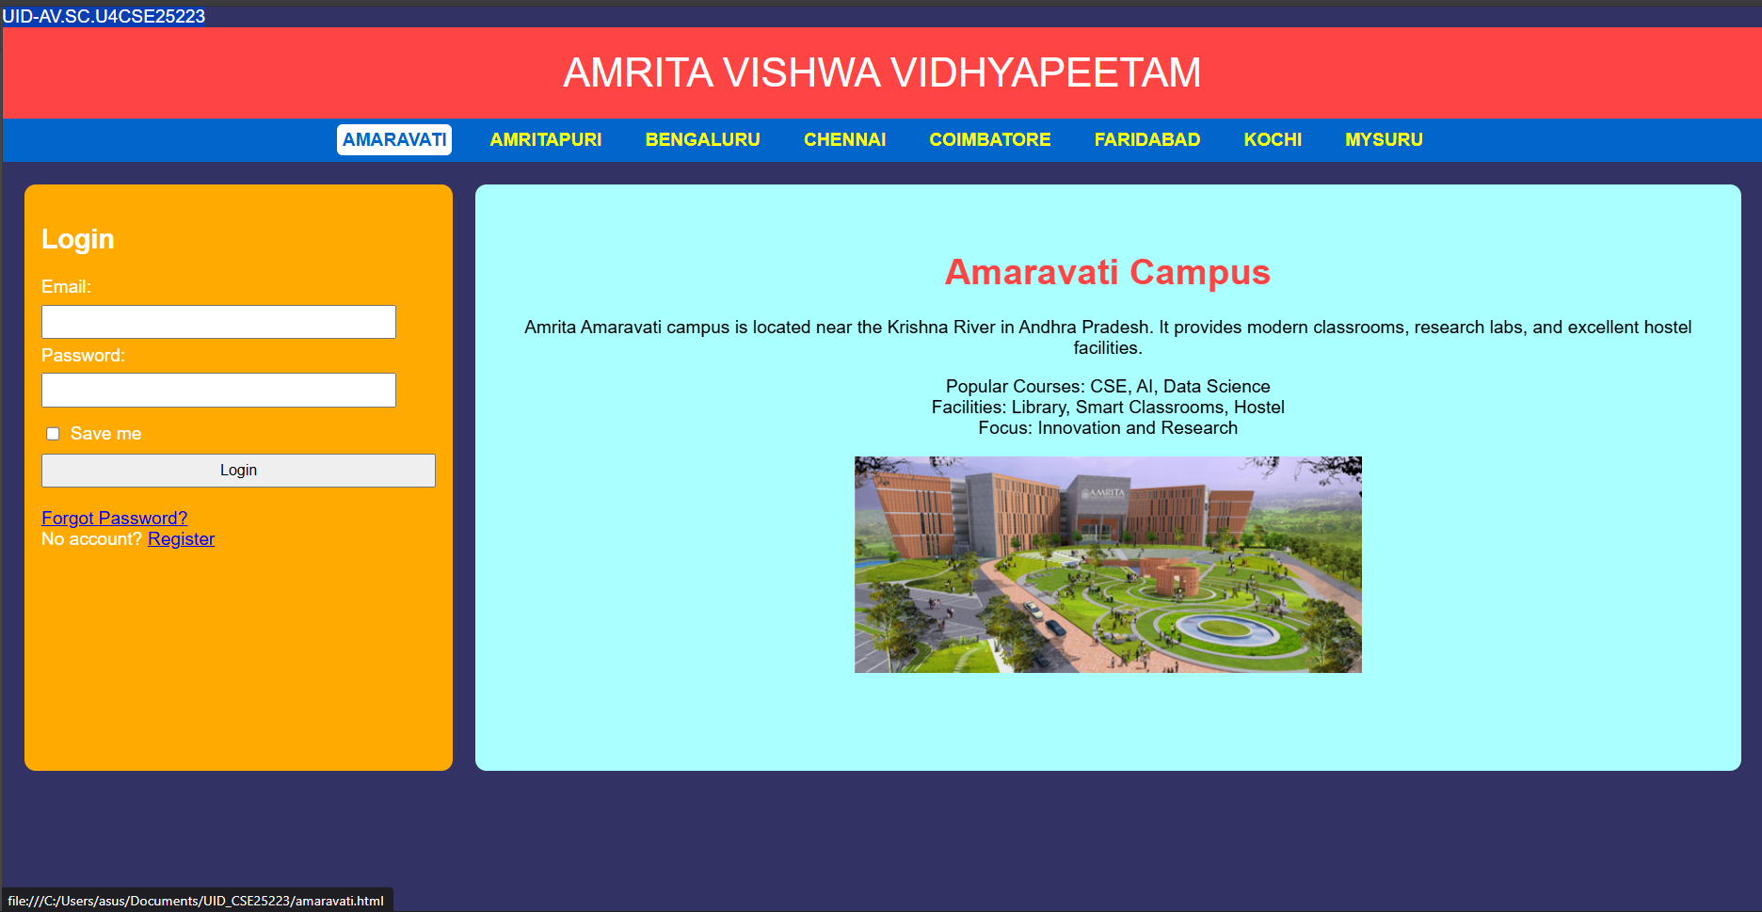
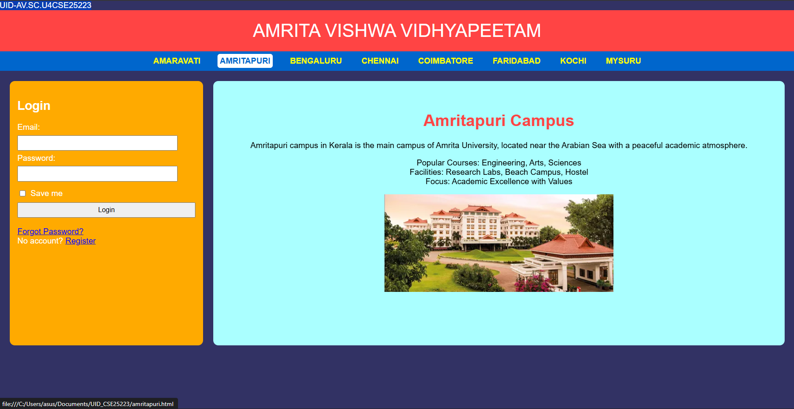
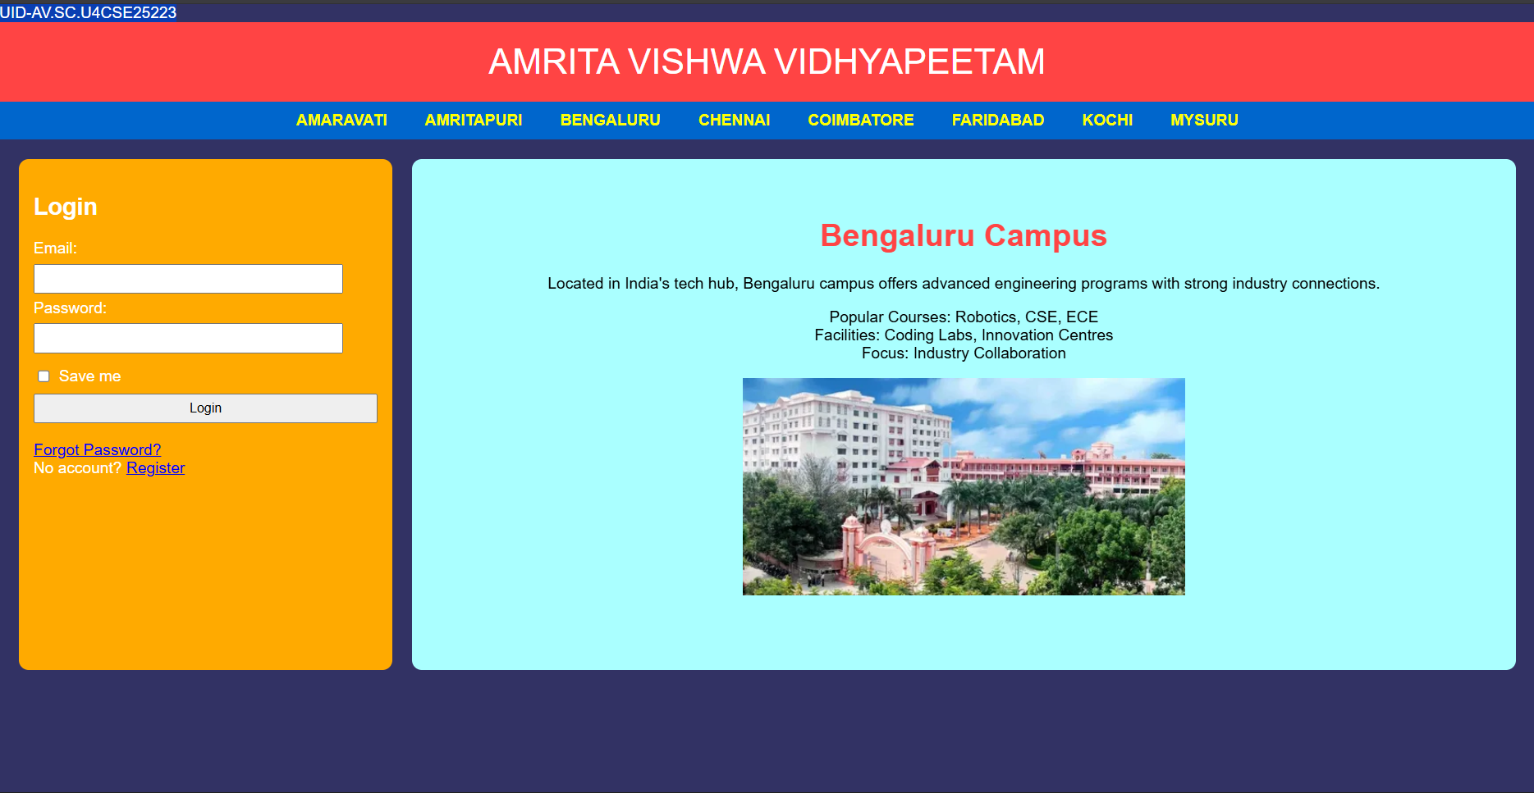

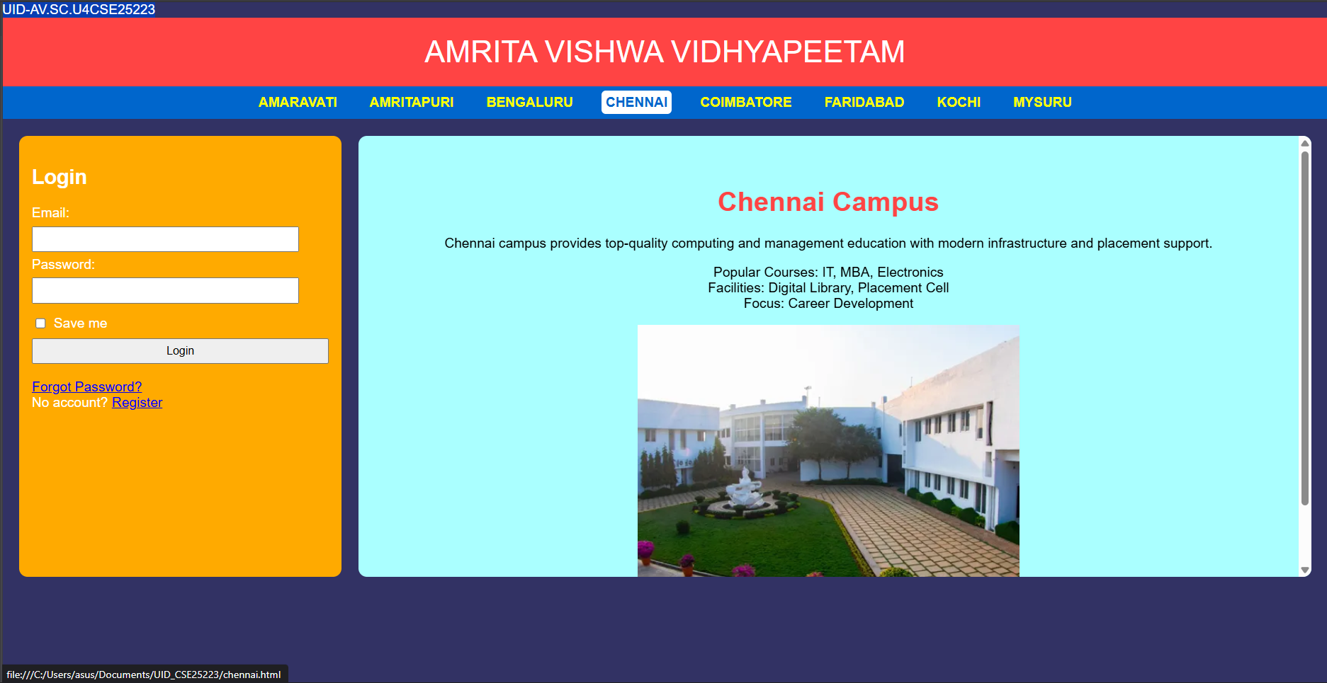
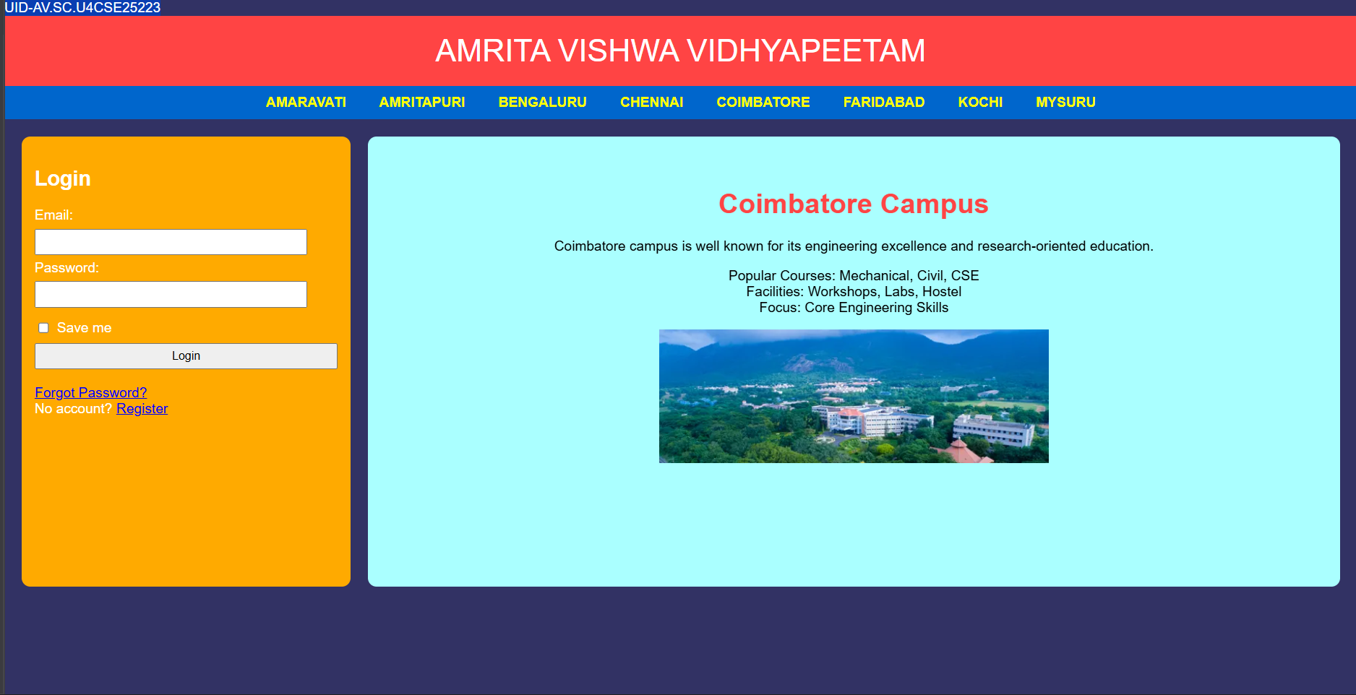
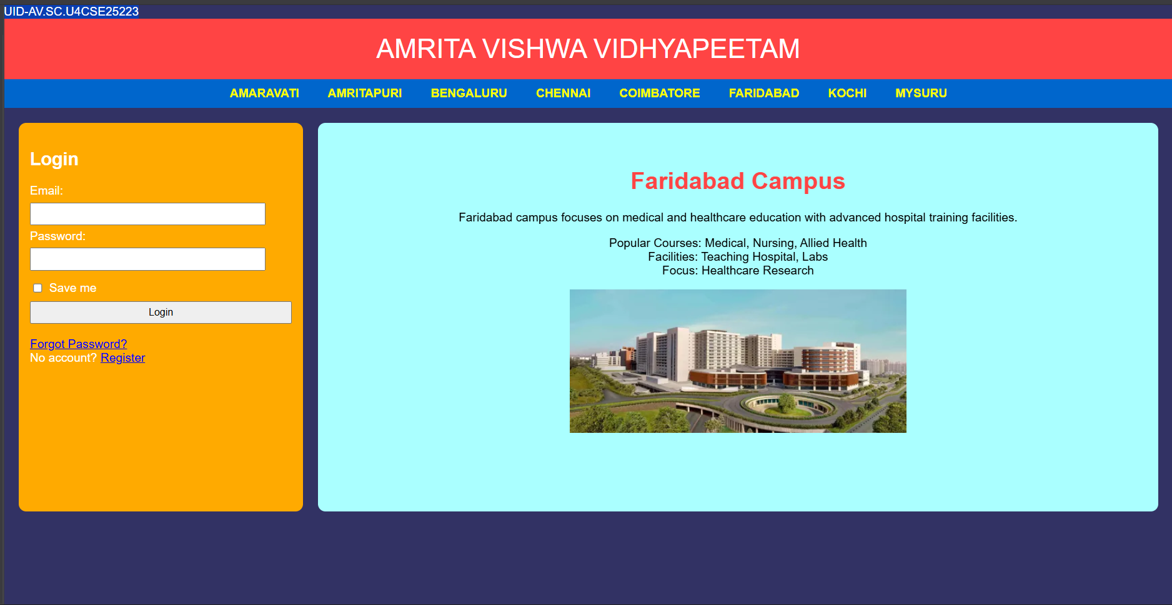
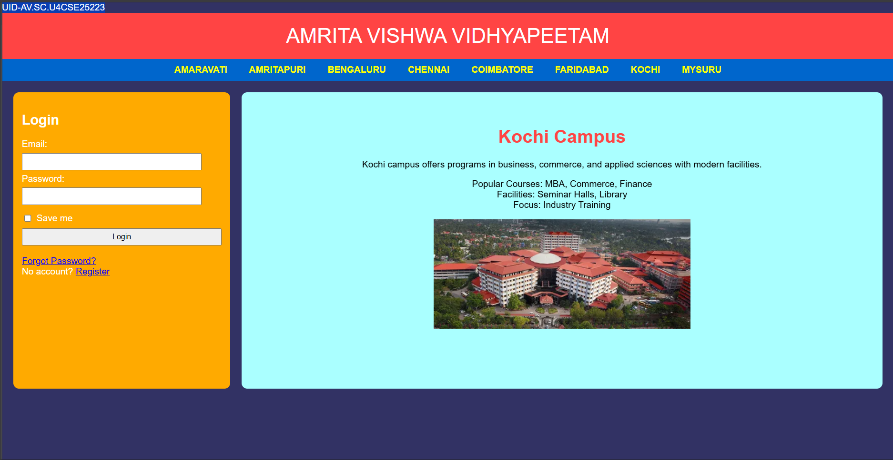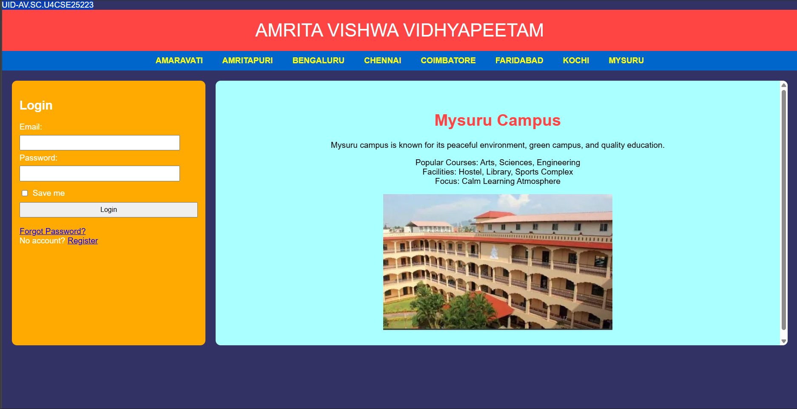
Explanation of the tags:
- header: Groups main title bar with bold styling (bright red background, large font).
- nav: Creates navigation bar with campus links (brighter blue background, centered).
- nav a:hover: Changes link appearance on mouseover (white background, blue text, rounded).
- main {display: flex}: Places login form and iframe side by side horizontally.
- .login: Styles login box (orange background, rounded corners, white text).
- .remember {display: flex}: Aligns checkbox and "Save me" label in a horizontal row.
- align-items: center: Vertically centers checkbox with its label.
- gap: 6px: Adds small space between checkbox and label.
- iframe {flex: 1}: Makes iframe take remaining width beside login box.
- target="campus": Loads campus pages inside specific iframe named "campus".
- name="campus": Names iframe so nav links target it specifically.

WEEK-6

6.A. Aim: Design a responsive e-commerce application using the grid layout. This application should contain different categories of products such as electronics, clothing, home-appliances, books.
Code:-
<!DOCTYPE html>
UID-CSE25223
<html>
<head>
<title>Gadget Hub</title>
<style>
body {
font-family: Arial, sans-serif;
margin: 0;
padding: 0;
background-color: #f4f4f4;
}
.container {
display: grid;
grid-template-rows: auto auto 1fr auto;
grid-template-columns: 200px 1fr;
grid-template-areas:
"header header"
"sale sale"
"sidebar main"
"footer footer";
gap: 10px;
padding: 10px;
}
.header {
grid-area: header;
background-color: #4CAF50;
padding: 10px;
text-align: center;
color: white;
}
.sale {
grid-area: sale;
background-color: #2196F3;
padding: 10px;
text-align: center;
color: white;
}
.sidebar {
grid-area: sidebar;
background-color: #FFEB3B;
padding: 10px;
}
.main {
grid-area: main;
background-color: white;
padding: 10px;
display: grid;
grid-template-columns: repeat(2, 1fr);
gap: 10px;
}
.footer {
grid-area: footer;
background-color: #FFC107;
padding: 10px;
text-align: center;
}
.product {
background-color: #e8f5e8;
padding: 10px;
border-radius: 5px;
text-align: center;
}
.product-image {
width: 200px;
height: 200px;
}
.button {
background-color: #FF5722;
color: white;
border: none;
padding: 10px 20px;
border-radius: 5px;
}
.button:hover {
background-color: #E64A19;
}
</style>
</head>
<body>
<div class="container">
<div class="header">
<h1>GADGET HUB</h1>
</div>
<div class="sale">
<p>Special Sale!</p>
</div>
<div class="sidebar">
<h2>Categories</h2>
<ul>
<li>Laptops</li>
<li>Smartphones</li>
<li>Headphones</li>
<li>Smart Watches</li>
</ul>
</div>
<div class="main">
<div class="product">
<img class="product-image" src="game.webp" alt="Gaming Laptop">
<h3>Gaming Laptop</h3>
<p>Price: $999.99</p>
<button class="button">Add to Cart</button>
</div>
<div class="product">
<img class="product-image" src="phone.webp" alt="Smartphone">
<h3>Flagship Smartphone</h3>
<p>Price: $799.99</p>
<button class="button">Add to Cart</button>
</div>
<div class="product">
<img class="product-image" src="wireless.webp" alt="Headphones">
<h3>Wireless Headphones</h3>
<p>Price: $149.99</p>
<button class="button">Add to Cart</button>
</div>
<div class="product">
<img class="product-image" src="watch.webp" alt="Smart Watch">
<h3>Smart Watch</h3>
<p>Price: $199.99</p>
<button class="button">Add to Cart</button>
</div>
</div>
<div class="footer">
<p>&copy; GADGET HUB Website. All rights reserved.</p>
</div>
</div>
</body>
</html>

Output:-
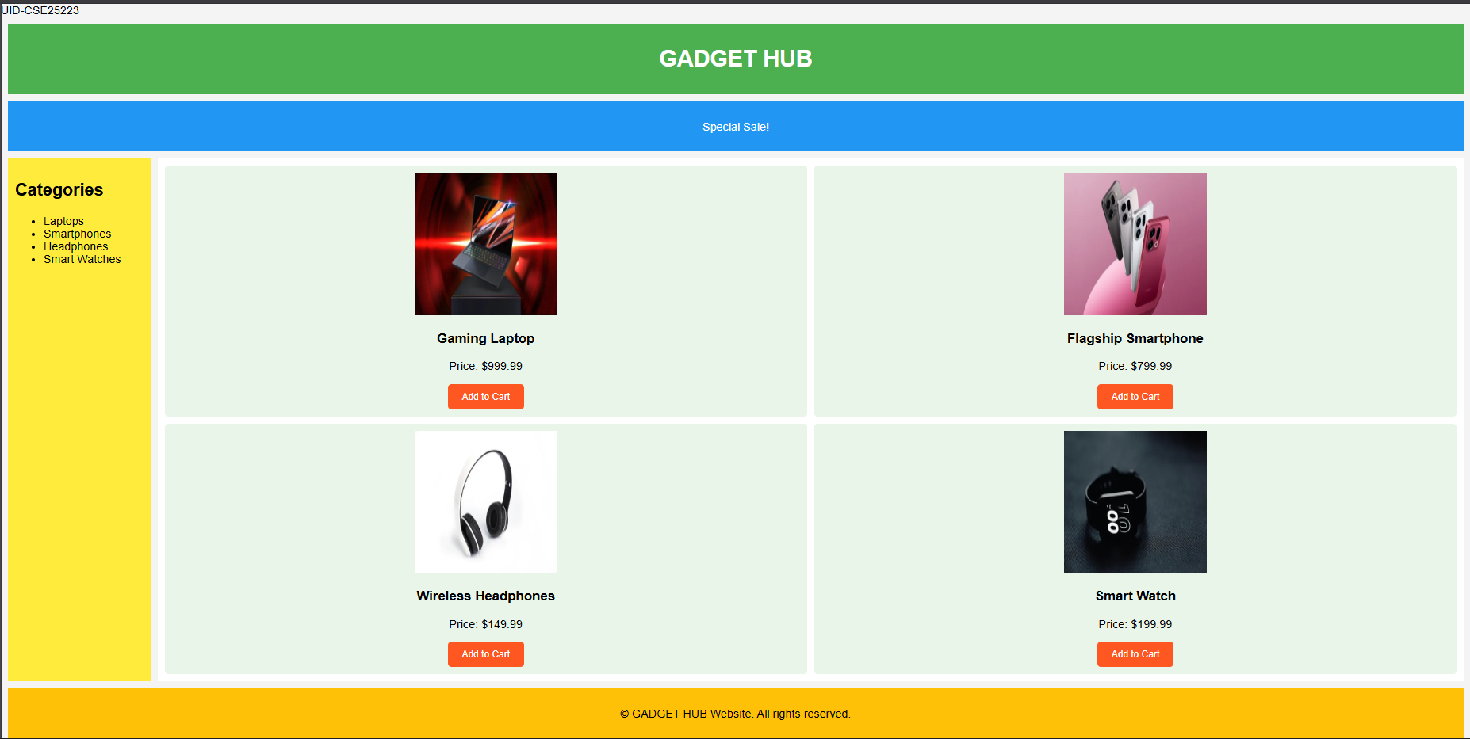

Explanation of the tags:
- display: grid: Enables CSS Grid layout system
- grid-template-areas: Defines 5 regions (header/sale/sidebar/main/footer)
- grid-area: header: Assigns element to header grid area
- grid-template-columns: 200px 1fr: Fixed 200px sidebar + flexible main
- gap: 10px: Spacing between all grid items
- padding: 10px: Inner spacing for all sections
- background-color: #4CAF50: Green header background
- text-align: center: Centers content in all sections
- repeat(2, 1fr): Creates 2-column product grid in main
- border-radius: 5px: Rounded corners on products/buttons
- .product-image { width: 200px; height: 200px }: Fixed-size product images
- background-color: #FF5722: Orange Add to Cart buttons
- :hover: Button darkens on mouseover (#E64A19)
- border: none: Removes button borders
- 1fr: Flexible units fill available space

6.B. Aim: Design a responsive e-commerce application using the grid layout. This application should contain different categories of products such as electronics, clothing, home-appliances, books. Based on the category we select corresponding products should be displayed on the sidebar.
Code:-

Main.html
<!DOCTYPE html>
<html>
<head>
<title>GADGET HUB</title>
<style>
body {
margin: 0;
font-family: Arial;
color: #333;
background: linear-gradient(135deg, #f5f7fa 0%, #c3cfe2 100%);
}
.container {
display: grid;
grid-template:
"header header" auto
"sale sale" auto
"sidebar main" 1fr
"footer footer" auto / 220px 1fr;
gap: 15px;
padding: 15px;
}
.header, .sale, .sidebar, .main, .footer {
background: rgba(255,255,255,.95);
border-radius: 12px;
padding: 15px;
box-shadow: 0 4px 20px rgba(0,0,0,0.1);
}
.header {
grid-area: header;
text-align: center;
font-size: 28px;
letter-spacing: 3px;
background: linear-gradient(45deg, #4CAF50, #45a049);
color: white;
}
.sale {
grid-area: sale;
overflow: hidden;
white-space: nowrap;
height: 40px;
position: relative;
background: linear-gradient(45deg, #2196F3, #21CBF3);
color: white;
font-weight: bold;
}
.sale p {
position: absolute;
font-size: 20px;
animation: move 10s linear infinite;
}
@keyframes move {
from { left: -100%; }
to { left: 100%; }
}
.sidebar {
grid-area: sidebar;
background: linear-gradient(135deg, #FFEB3B, #FF9800);
}
.sidebar ul { list-style: none; padding: 0; }
.sidebar li { margin: 15px 0; }
.sidebar a {
color: #333;
text-decoration: none;
font-size: 18px;
transition: .3s;
display: block;
}
.sidebar a:hover {
color: #2196F3;
padding-left: 8px;
background: rgba(255,255,255,0.5);
border-radius: 6px;
}
.main {
grid-area: main;
background: white;
}
iframe {
width: 100%;
height: 520px;
border: 0;
border-radius: 10px;
box-shadow: 0 4px 15px rgba(0,0,0,0.1);
}
.footer {
grid-area: footer;
text-align: center;
font-size: 14px;
background: linear-gradient(45deg, #FFC107, #FF9800);
color: #333;
}
</style>
</head>
<body>
<div class="container">
<div class="header">GADGET HUB</div>
<div class="sale">
<p>🔥 SPECIAL SALE – UP TO 50% OFF ON GADGETS 🔥</p>
</div>
<div class="sidebar">
<h2>Categories</h2>
<ul>
<li><a href="laptops.html" target="contentFrame">LAPTOPS</a></li>
<li><a href="smartphones.html" target="contentFrame">SMARTPHONES</a></li>
<li><a href="headphones.html" target="contentFrame">HEADPHONES</a></li>
<li><a href="smartwatches.html" target="contentFrame">SMART WATCHES</a></li>
</ul>
</div>
<div class="main">
<iframe name="contentFrame"></iframe>
</div>
<div class="footer">© GADGET HUB Website</div>
</div>
</body>
</html>

laptops.html
<!DOCTYPE html>
<html>
<head>
<title>Laptops</title>
<style>
body {
font-family: Arial, sans-serif;
margin: 0;
padding: 20px;
background: linear-gradient(135deg, #f5f7fa 0%, #c3cfe2 100%);
}
.container {
display: grid;
grid-template-columns: 1fr 1fr;
gap: 20px;
}
.card {
background: white;
padding: 20px;
border-radius: 15px;
box-shadow: 0 8px 25px rgba(0,0,0,0.1);
text-align: center;
}
.card-img {
width: 200px;
height: 200px;
border-radius: 12px;
margin-bottom: 15px;
}
.price {
font-size: 20px;
color: #4CAF50;
font-weight: bold;
}
</style>
</head>
<body>
<div class="container">
<div class="card">
<img class="card-img" src="game.webp" alt="Gaming Laptop">
<h2>GAMING PRO</h2>
<p>RTX 4080 gaming laptop</p>
<p class="price">$999.99</p>
</div>
<div class="card">
<img class="card-img" src="ultrabook.webp" alt="Ultrabook">
<h2>ULTRABOOK</h2>
<p>Lightweight productivity laptop</p>
<p class="price">$799.99</p>
</div>
<div class="card">
<img class="card-img" src="creator.webp" alt="Creator Laptop">
<h2>CREATOR STUDIO</h2>
<p>4K video editing laptop</p>
<p class="price">$1299.99</p>
</div>
<div class="card">
<img class="card-img" src="business.webp" alt="Business Laptop">
<h2>BUSINESS ELITE</h2>
<p>Enterprise grade laptop</p>
<p class="price">$899.99</p>
</div>
</div>
</body>
</html>

smartphones.html
<!DOCTYPE html>
<html>
<head>
<title>Smartphones</title>
<style>
body {
font-family: Arial, sans-serif;
margin: 0;
padding: 20px;
background: linear-gradient(135deg, #f5f7fa 0%, #c3cfe2 100%);
}
.container {
display: grid;
grid-template-columns: 1fr 1fr;
gap: 20px;
}
.card {
background: white;
padding: 20px;
border-radius: 15px;
box-shadow: 0 8px 25px rgba(0,0,0,0.1);
text-align: center;
}
.card-img {
width: 200px;
height: 200px;
border-radius: 12px;
margin-bottom: 15px;
}
.price {
font-size: 20px;
color: #4CAF50;
font-weight: bold;
}
</style>
</head>
<body>
<div class="container">
<div class="card">
<img class="card-img" src="ultra.webp" alt="Flagship Phone">
<h2>ULTRA PRO</h2>
<p>Latest flagship smartphone</p>
<p class="price">$799.99</p>
</div>
<div class="card">
<img class="card-img" src="phone.webp" alt="Midrange Phone">
<h2>MIDRANGE X</h2>
<p>Best value smartphone</p>
<p class="price">$499.99</p>
</div>
<div class="card">
<img class="card-img" src="gaming.webp" alt="Gaming Phone">
<h2>GAMER PHONE</h2>
<p>120Hz gaming smartphone</p>
<p class="price">$649.99</p>
</div>
<div class="card">
<img class="card-img" src="fold.webp" alt="Foldable Phone">
<h2>FOLD PRO</h2>
<p>Foldable display smartphone</p>
<p class="price">$999.99</p>
</div>
</div>
</body>
</html>

smartwatches.html

<!DOCTYPE html>
<html>
<head>
<title>Smart Watches</title>
<style>
body {
font-family: Arial, sans-serif;
margin: 0;
padding: 20px;
background: linear-gradient(135deg, #f5f7fa 0%, #c3cfe2 100%);
}
.container {
display: grid;
grid-template-columns: 1fr 1fr;
gap: 20px;
}
.card {
background: white;
padding: 20px;
border-radius: 15px;
box-shadow: 0 8px 25px rgba(0,0,0,0.1);
text-align: center;
}
.card-img {
width: 200px;
height: 200px;
border-radius: 12px;
margin-bottom: 15px;
}
.price {
font-size: 20px;
color: #4CAF50;
font-weight: bold;
}
</style>
</head>
<body>
<div class="container">
<div class="card">
<img class="card-img" src="s9.webp" alt="Premium Smartwatch">
<h2>PREMIUM S9</h2>
<p>Advanced health tracking watch</p>
<p class="price">$199.99</p>
</div>
<div class="card">
<img class="card-img" src="fit.webp" alt="Fitness Tracker">
<h2>FIT TRACKER</h2>
<p>24/7 fitness monitoring</p>
<p class="price">$129.99</p>
</div>
<div class="card">
<img class="card-img" src="sports.webp" alt="Sports Watch">
<h2>SPORTS PRO</h2>
<p>GPS running and cycling watch</p>
<p class="price">$249.99</p>
</div>
<div class="card">
<img class="card-img" src="watch.webp" alt="Classic Smartwatch">
<h2>CLASSIC SERIES</h2>
<p>Traditional smartwatch design</p>
<p class="price">$179.99</p>
</div>
</div>
</body>
</html>

headphones.html

<!DOCTYPE html>
<html>
<head>
<title>Headphones</title>
<style>
body {
font-family: Arial, sans-serif;
margin: 0;
padding: 20px;
background: linear-gradient(135deg, #f5f7fa 0%, #c3cfe2 100%);
}
.container {
display: grid;
grid-template-columns: 1fr 1fr;
gap: 20px;
}
.card {
background: white;
padding: 20px;
border-radius: 15px;
box-shadow: 0 8px 25px rgba(0,0,0,0.1);
text-align: center;
}
.card-img {
width: 200px;
height: 200px;
border-radius: 12px;
margin-bottom: 15px;
}
.price {
font-size: 20px;
color: #4CAF50;
font-weight: bold;
}
</style>
</head>
<body>
<div class="container">
<div class="card">
<img class="card-img" src="premium.webp" alt="Wireless Over-ear">
<h2>PREMIUM OVER-EAR</h2>
<p>ANC wireless headphones</p>
<p class="price">$149.99</p>
</div>
<div class="card">
<img class="card-img" src="wireless.webp" alt="True Wireless">
<h2>TRUE WIRELESS</h2>
<p>Compact earbuds with case</p>
<p class="price">$79.99</p>
</div>
<div class="card">
<img class="card-img" src="gami.webp" alt="Gaming Headset">
<h2>GAMING HEADSET</h2>
<p>7.1 surround sound headset</p>
<p class="price">$99.99</p>
</div>
<div class="card">
<img class="card-img" src="studio.webp" alt="Studio Headphones">
<h2>STUDIO PRO</h2>
<p>Professional monitoring headphones</p>
<p class="price">$199.99</p>
</div>
</div>
</body>
</html>

Output:
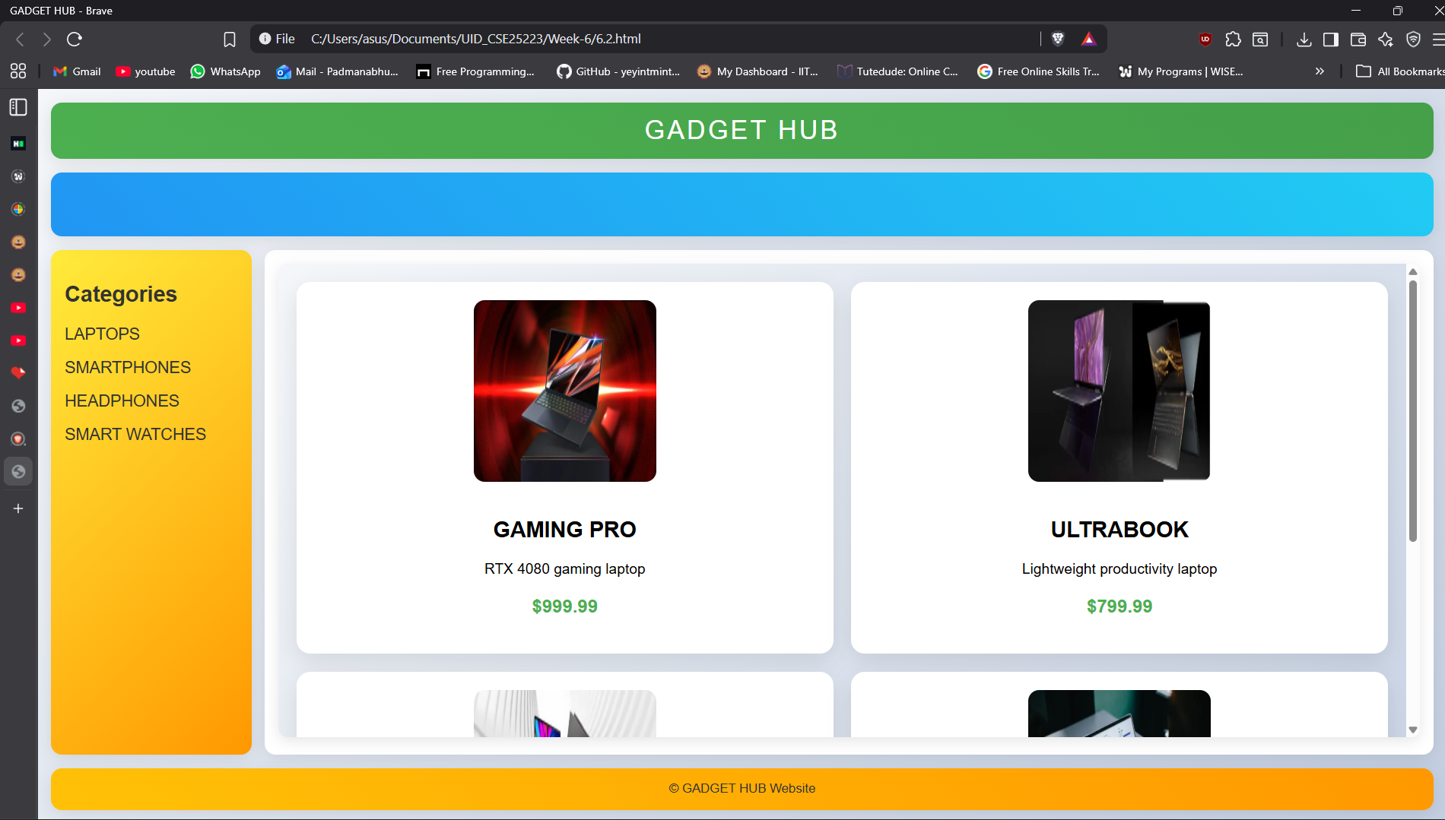
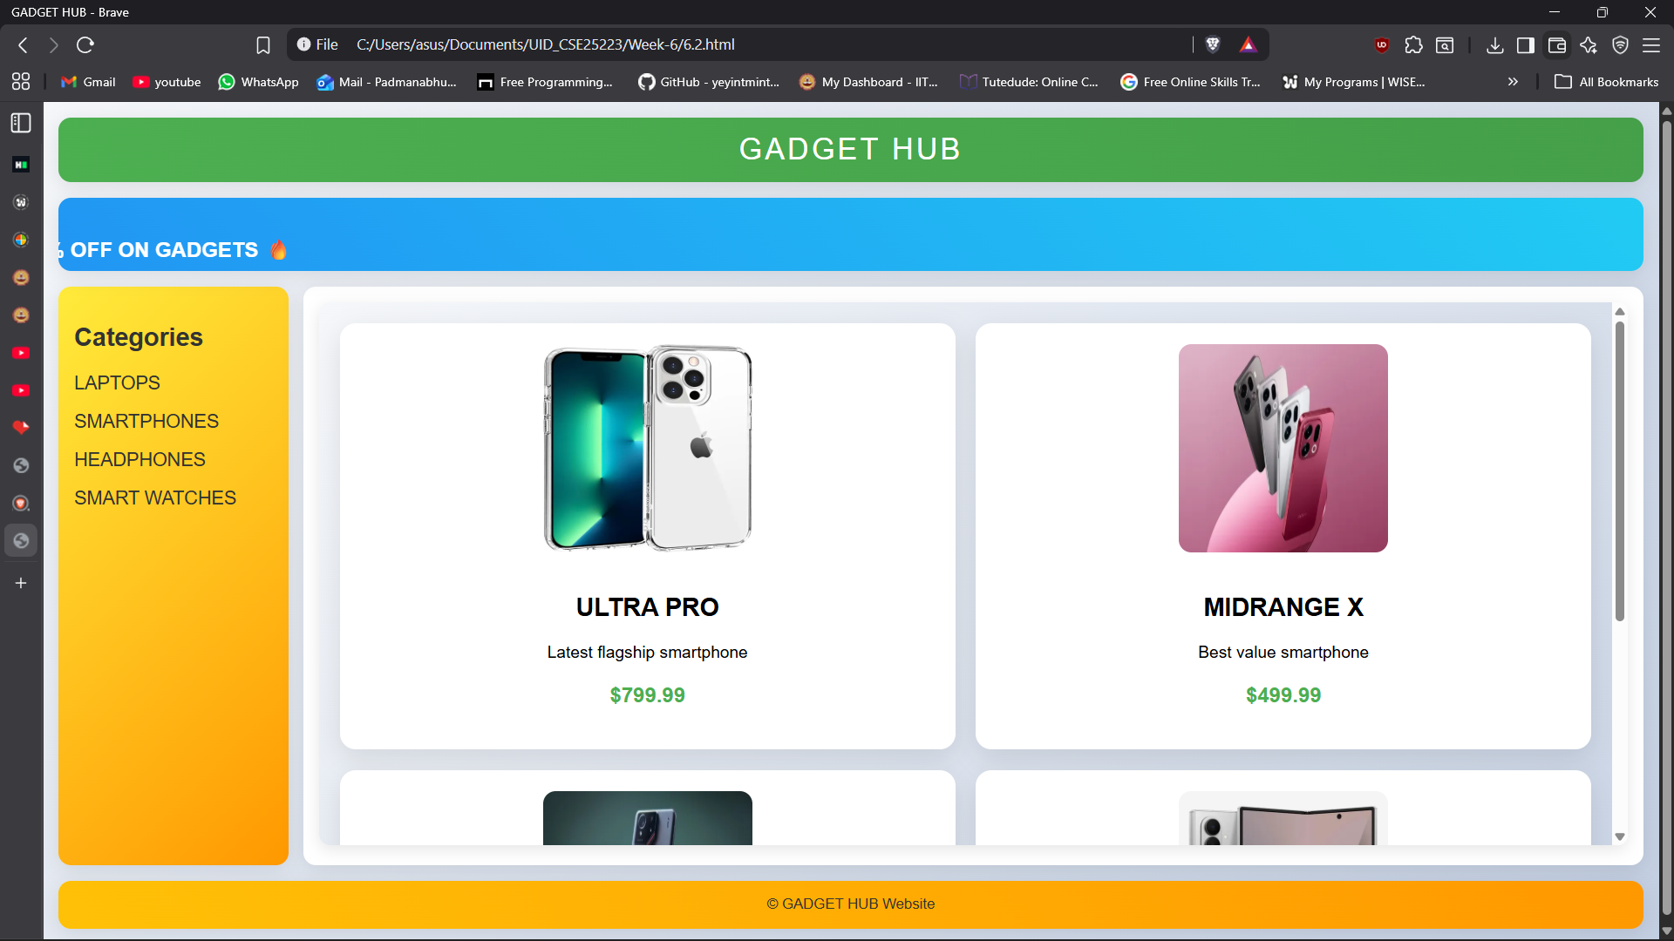
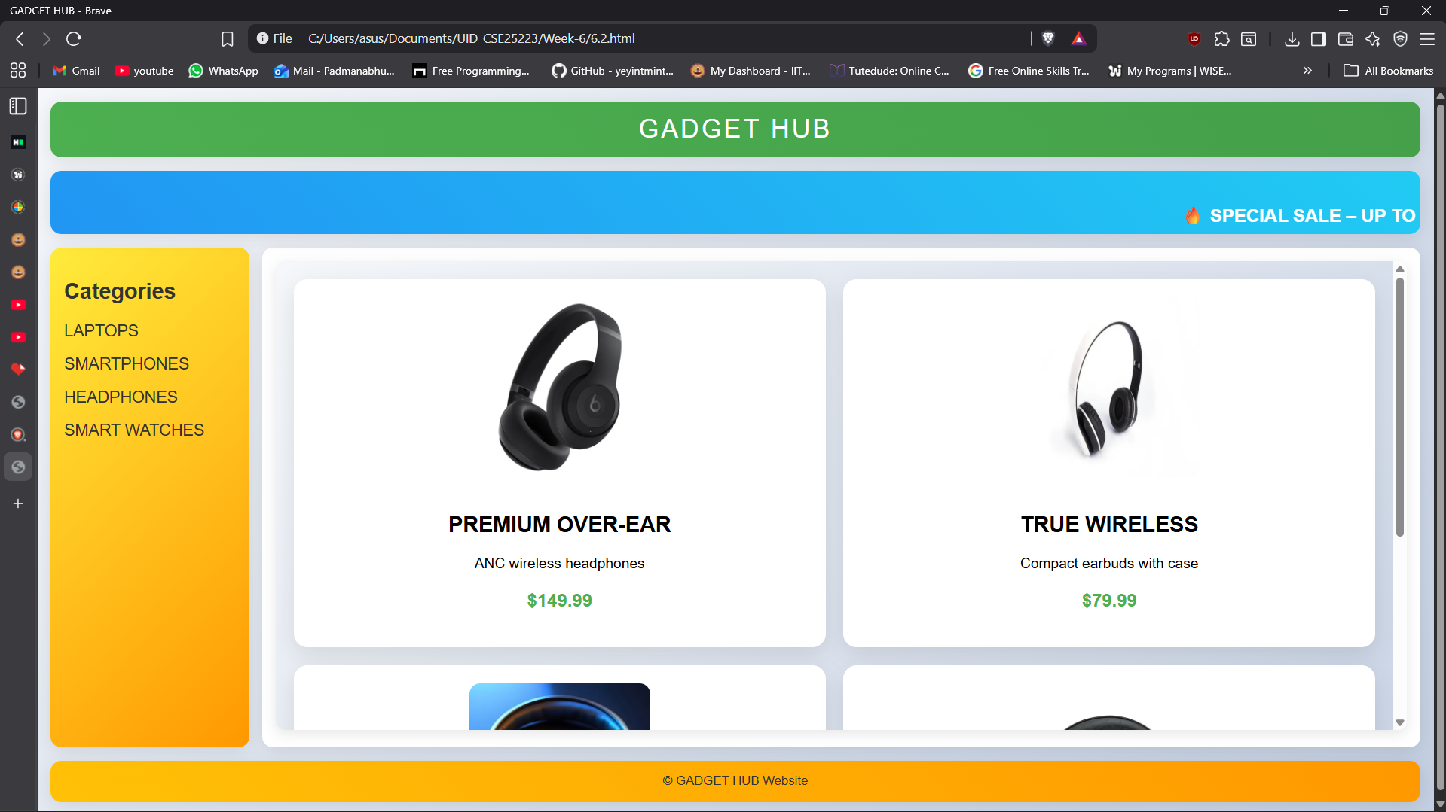
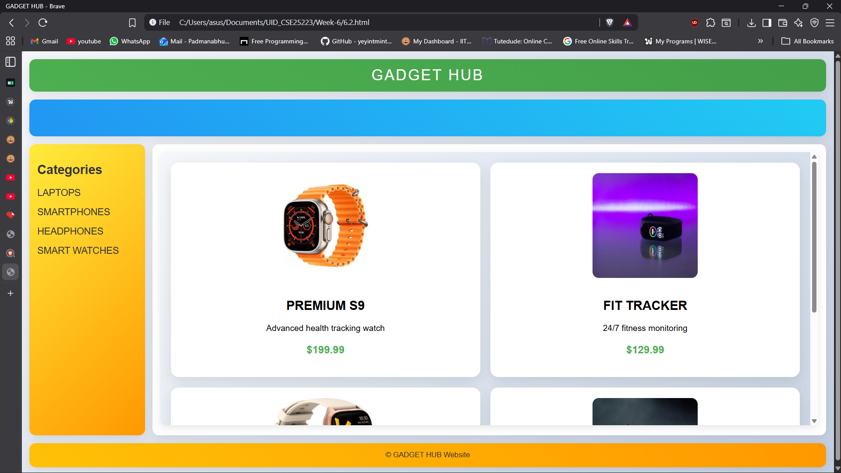

Explanation of the tags:
- target="contentFrame": Loads linked pages inside specific iframe by name
- name="contentFrame": Names iframe so menu links can target it
- grid-template: CSS Grid shorthand for rows, columns, and areas
- grid-area: header: Assigns element to named grid area
- linear-gradient(135deg, #f5f7fa 0%, #c3cfe2 100%): Light theme background gradient
- @keyframes move: Creates scrolling sale text animation
- animation: move 10s linear infinite: Continuous movement of sale banner text
- box-shadow: 0 4px 20px rgba(0,0,0,0.1): Adds soft shadow around sections/cards
- transition: .3s: Smooth hover effect on sidebar links
- display: block: Makes sidebar links take full line width
- border-radius: 10px: Rounds iframe corners
- grid-template-columns: 1fr 1fr: Creates 2-column product layout in sub-pages
- rgba(255,255,255,.95): Semi-transparent white section background
- font-weight: bold: Makes text thicker for emphasis
- letter-spacing: 3px: Adds spacing between header letters

WEEK-7
7.Aim: Create a Github Repository and upload all related files of lab manual.
Procedure:
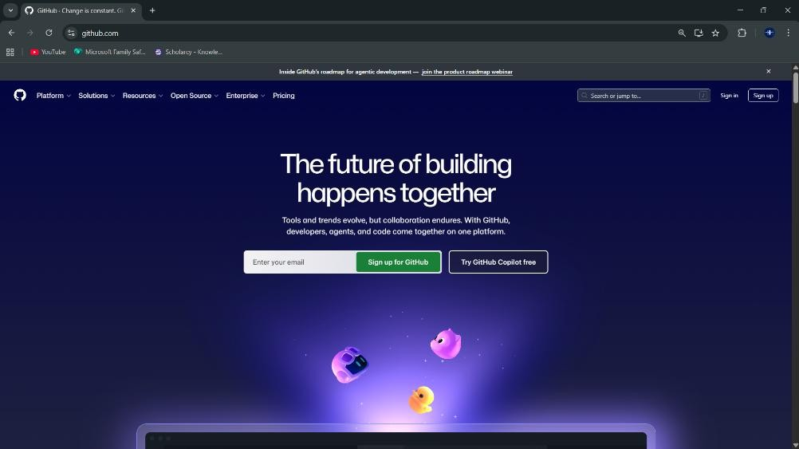
Step-1: Browse to Github and create an Account.

Step-2:Login to Github and Create a Repository
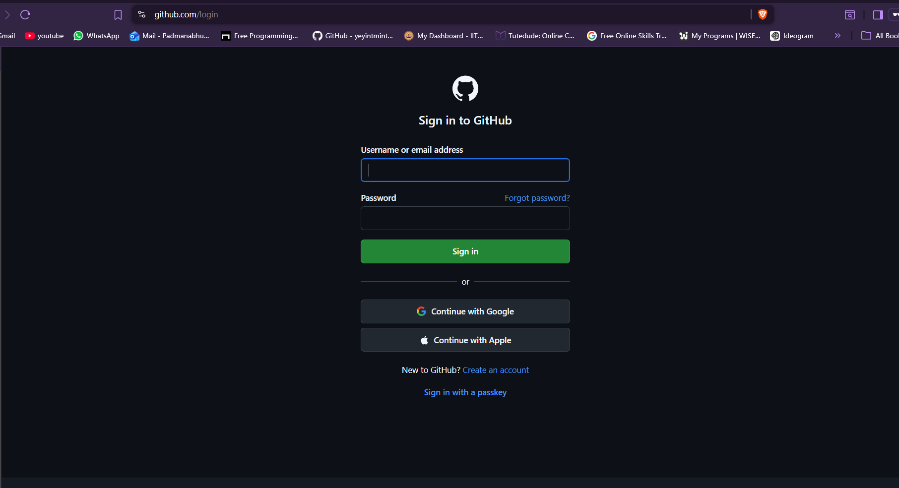

Step-3: Create a repository after login by clicking new.
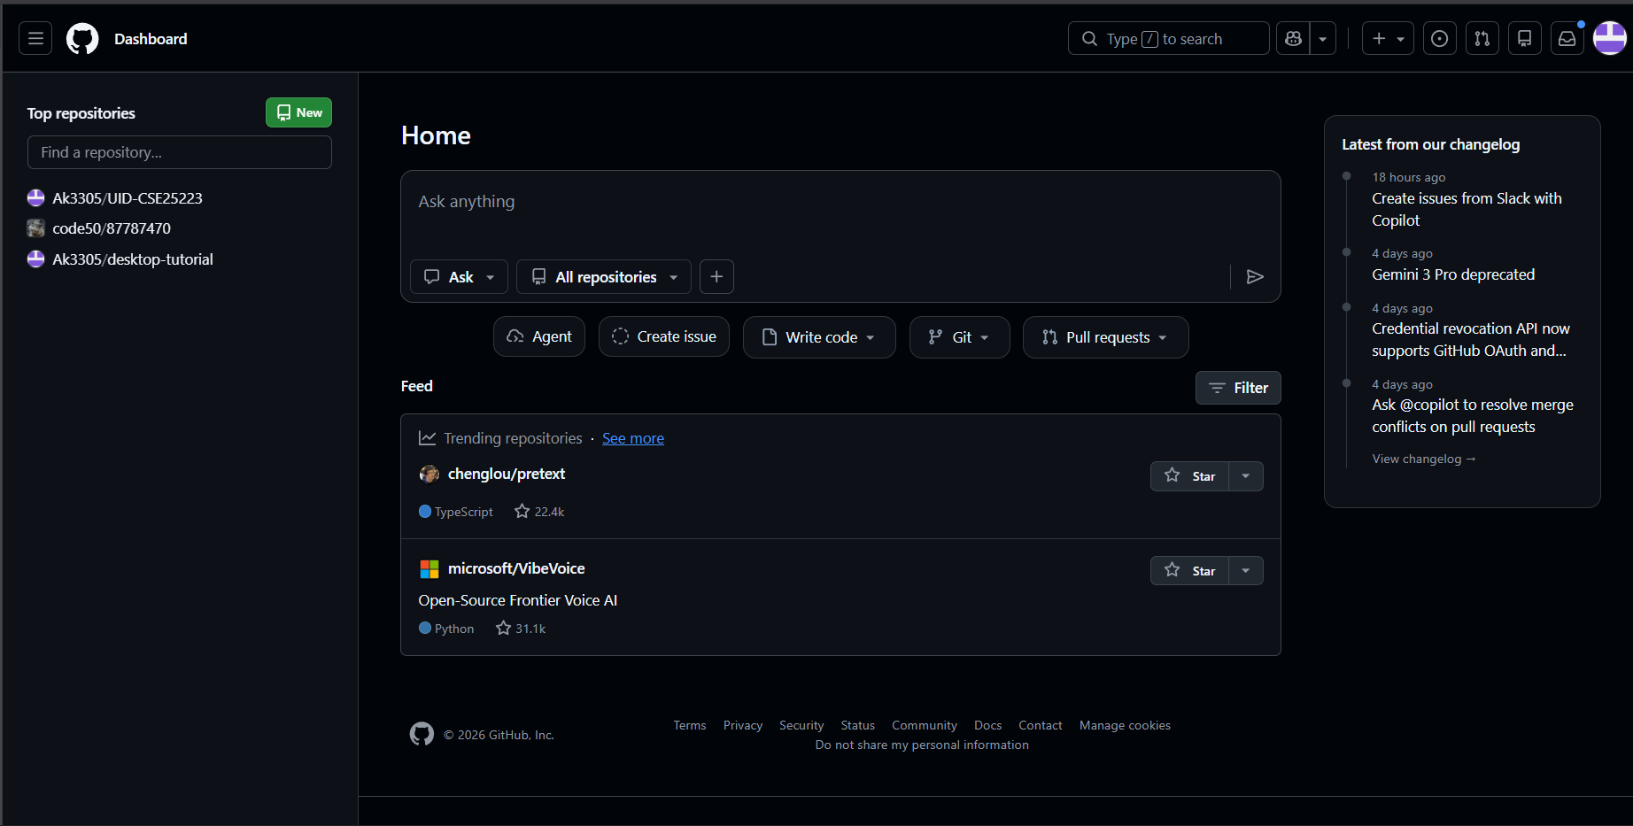
Step-4: Specify the Repository specifications
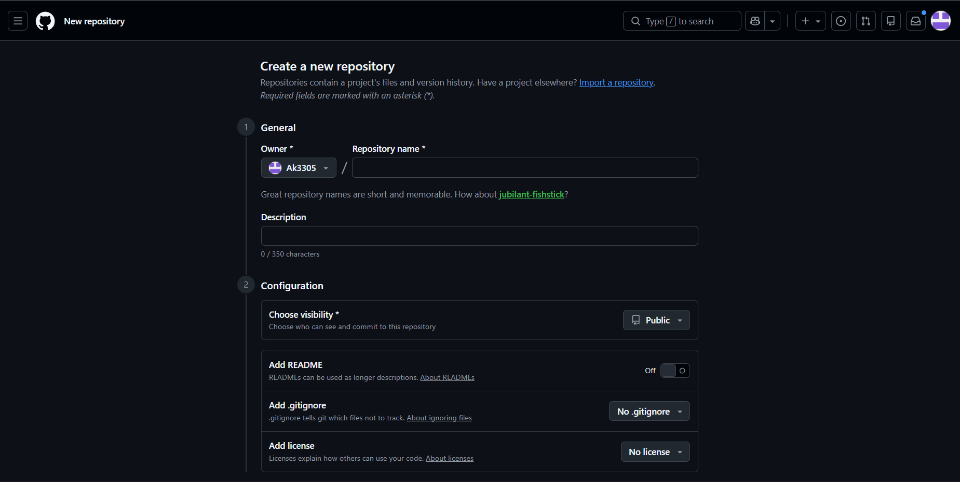
Step-5: Download Github Desktop and Launch it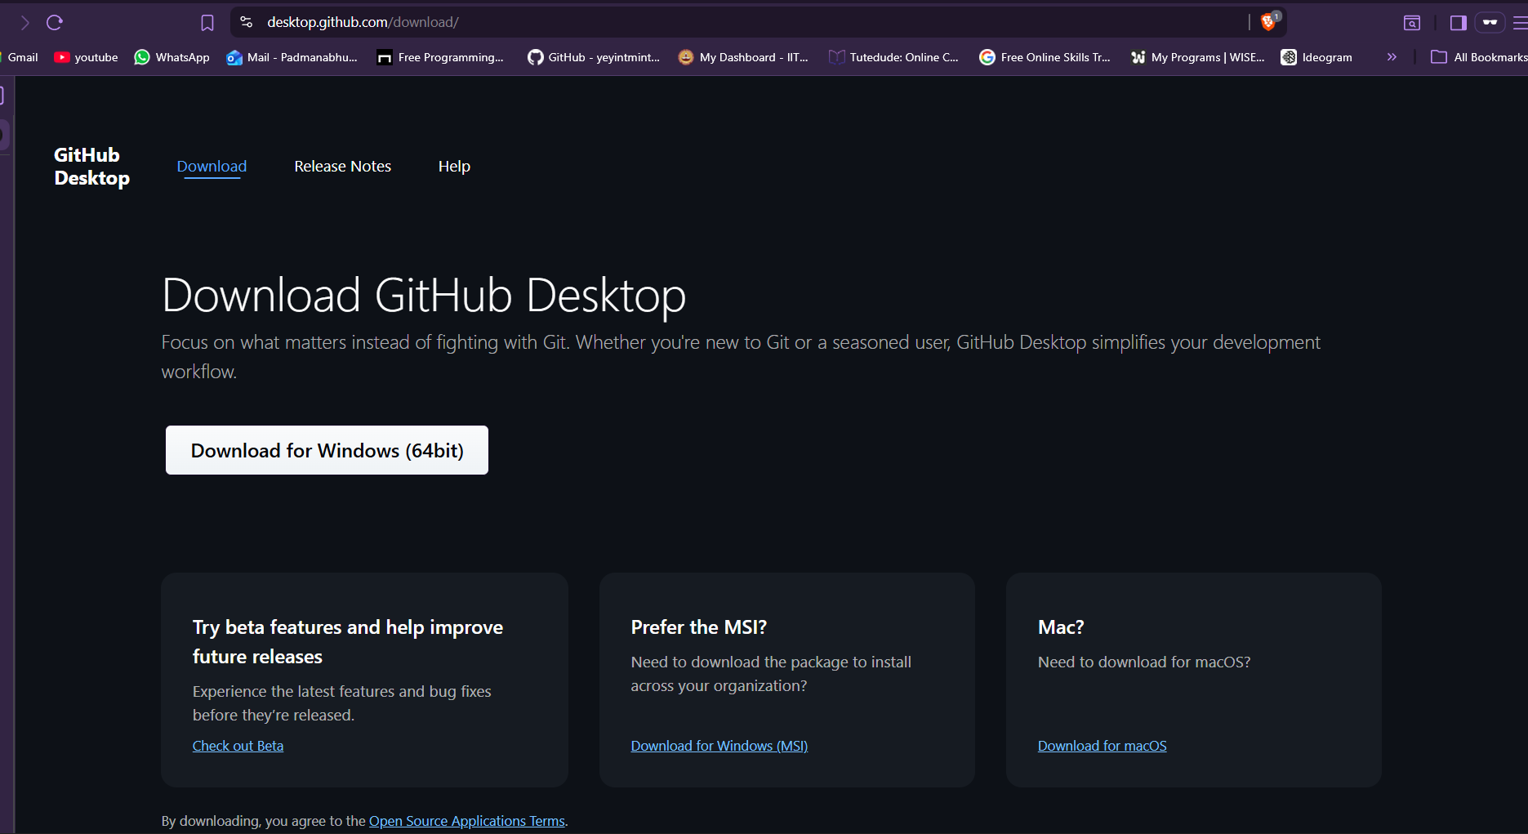

Step-6:In Github Desktop app setup a folder from your explorer.
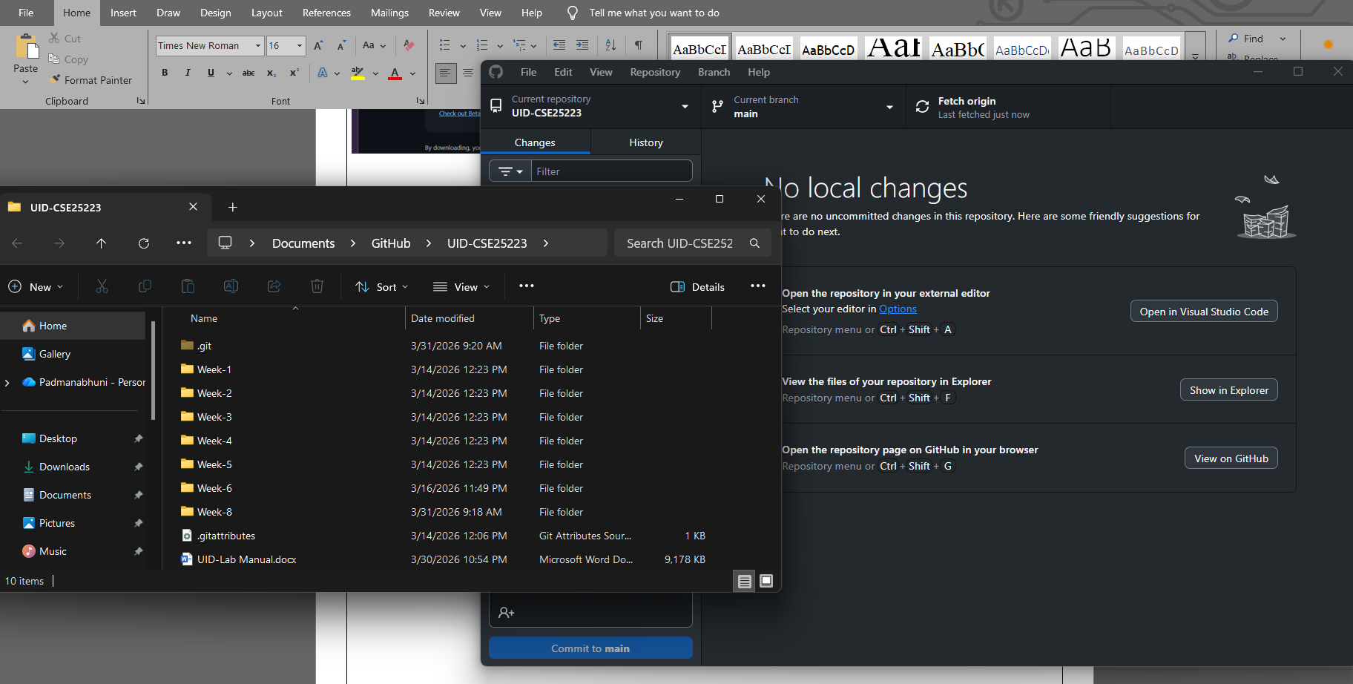

Step-7:Add all Week files to the folder linked to Github.
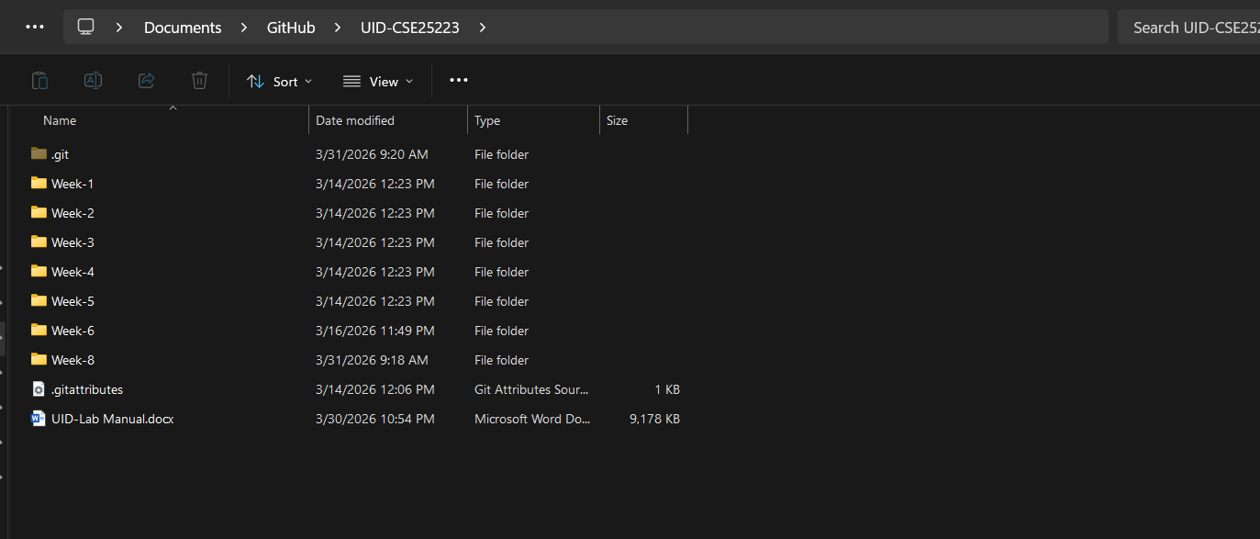
Step-8:Now click on Commit changes and Push the files in the GithubDesktop Applications.
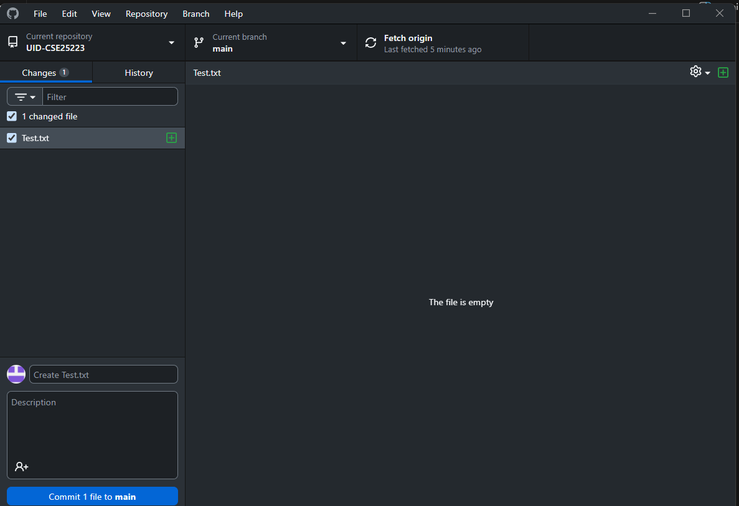
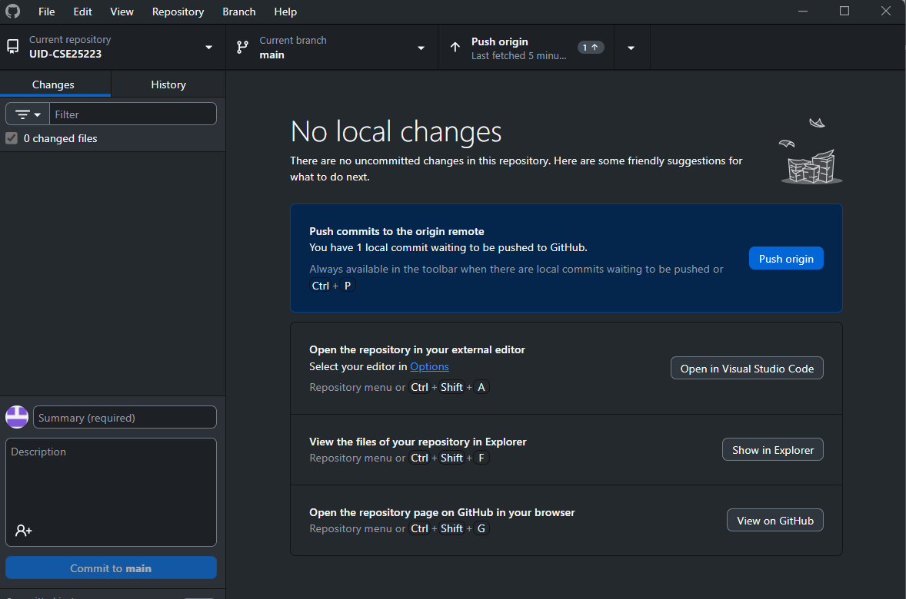
Step-9: Now go to browser and check it. All the new added files in the repository .
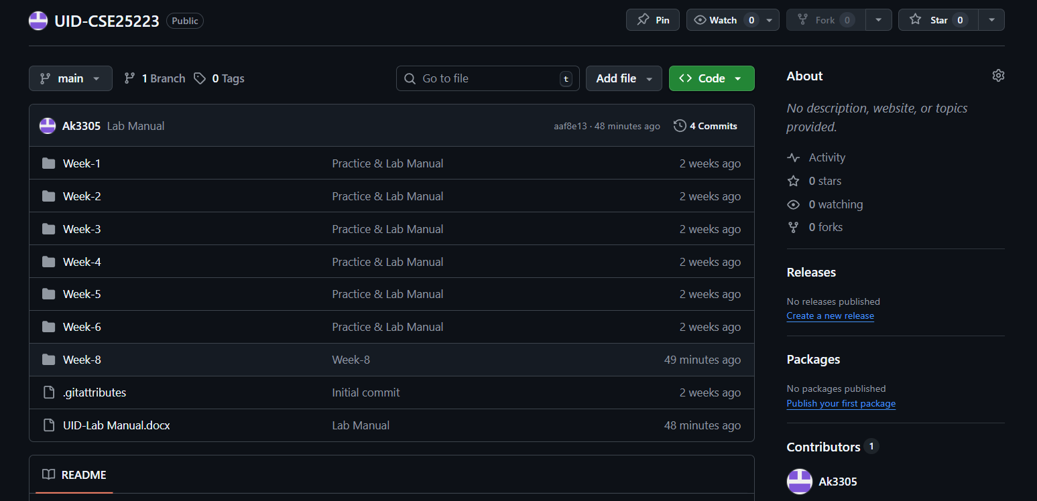
Link:- https://github.com/Ak3305/UID-CSE25223

WEEK-8
8.A.Aim: Create a webpage that displays a square that continuously rotates 360
degree using CSS Animation.
Code:
<!DOCTYPE html>
<head>
AV.SC.U4CSE25223
<style>
div {
width: 100px;
height: 100px;
background: whitesmoke;
margin: 100px auto;
animation: mymove 5s infinite linear;
}

@keyframes mymove {
from {transform: rotate(0deg);}
to {transform: rotate(360deg);}
}
</style>
</head>

<body style="background-color: greenyellow;">
<div></div>
</body>
Output:
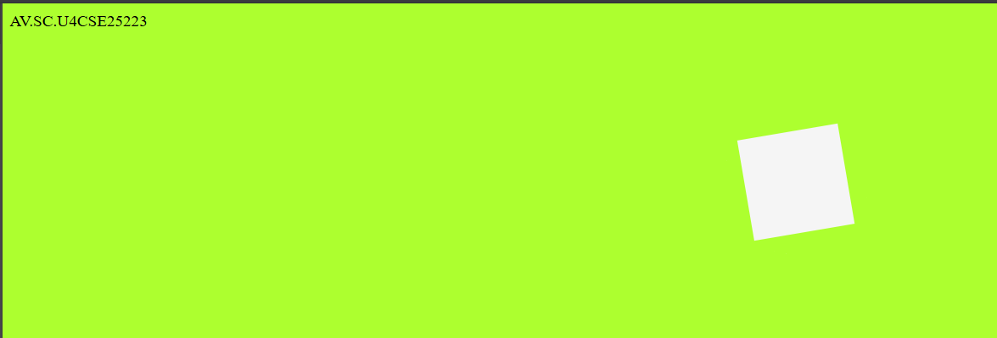
Explanation of the tags:
• animation: mymove 5s infinite linear: Runs animation for 5s, repeats forever, linear speed.
• @keyframes mymove: Defines animation steps from start to end
• transform: rotate(0deg): Rotates element 0 degrees (start position)
• transform: rotate(360deg): Rotates element full circle (end position)
• width: 100px; height: 100px: Creates square shape
• margin: 100px auto: Centers square horizontally, adds top spacing
• background: whitesmoke: Light gray square color

8.B.Aim: Create a ball that moves up and down continuously using CSS Animation.
Code:
<!DOCTYPE html>
<head>
AV.SC.U4CSE25223
<style>
div {
width: 100px;
height: 100px;
background: whitesmoke;
border-radius: 50%;
position: relative;
animation: mymove 2s infinite alternate;
}

@keyframes mymove {
from {top: 0px;}
to {top: 200px;}
}
</style>
</head>

<body style="background-color: greenyellow;">
<div></div>
</body>
Output:
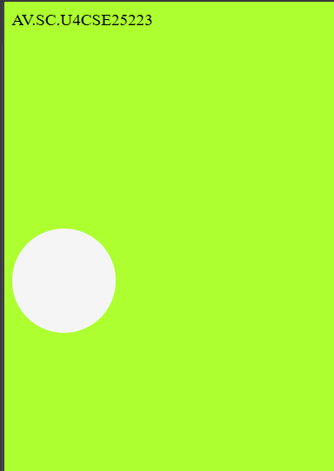

Explanation of the tags:
• border-radius: 50%: Makes square into perfect circle
• position: relative: Allows top positioning from original spot
• animation: mymove 2s infinite alternate: Bounces up/down every 2s, reverses direction
• top: 0px: Starting position at top
• top: 200px: Ending position 200px down
• @keyframes mymove: Defines bounce path from top to bottom
• width/height: Creates circular ball shape
• infinite alternate: Keeps bouncing back and forth

8.C.Aim: Create a circle that moves horizontally and rotates at the same time
using CSS Animation.
Code:
<!DOCTYPE html>
<head>
AV.SC.U4CSE25223
<style>
div {
width: 100px;
height: 100px;
background: whitesmoke;
border-radius: 50%;
position: relative;
animation: mymove 5s infinite linear;
}
@keyframes mymove {
from {
left: 0px;
transform: rotate(0deg);
}
to {
left: 200px;
transform: rotate(360deg);
}
}
</style>
</head>
<body style="background-color: greenyellow;">
<div></div>
</body>

Output:
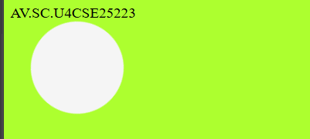

Explanation of the tags:
• border-radius: 50%: Makes square into perfect circle
• position: relative: Allows top positioning from original spot
• animation: mymove 2s infinite alternate: Bounces up/down every 2s, reverses direction
• top: 0px: Starting position at top
• top: 200px: Ending position 200px down
• @keyframes mymove: Defines bounce path from top to bottom
• width/height: Creates circular ball shape
• infinite alternate: Keeps bouncing back and forth

WEEK-9
9.Aim: Create a webpage using HTML, CSS, JS based on the give conditions:
a) Create a button for each program, based on the button, clicked the corresponding program has to be executed and should display the output.
b)The logics for each button includes finding an even or odd number, prime or not, factorial of a number, Armstrong or not.
c)Use appropriate design to display the output.
Code:
<!DOCTYPE html>
<html>
<head>
<title>Logic Programs</title>
<style>
body {
margin: 0;
font-family: Arial, sans-serif;
background: #e6ecf5;
display: flex;
justify-content: center;
align-items: center;
min-height: 100vh;
}
.container {
background: #ffffff;
border-radius: 12px;
box-shadow: 0 4px 20px rgba(0,0,0,0.2);
padding: 40px;
width: 380px;
text-align: center;
}
h2 {
margin-bottom: 20px;
color: #2c3e50;
}
input {
width: 100%;
padding: 10px;
font-size: 16px;
border: 2px solid #a7b6c7;
border-radius: 8px;
margin-bottom: 20px;
box-sizing: border-box;
text-align: center;

background: #f8fbff;
color: #333;
}
input:focus {
outline: none;
border-color: #5b8def;
}
.buttons {
display: grid;
grid-template-columns: 1fr 1fr;
gap: 12px;
margin-bottom: 24px;
}
button {
padding: 12px;
font-size: 15px;
border: none;
border-radius: 8px;
cursor: pointer;
color: white;
font-weight: bold;
background: #5b8def;
transition: opacity 0.2s;
}
button:hover { opacity: 0.85; }
.output {
background: #eef3f8;

padding: 20px;
border-radius: 8px;
min-height: 60px;
color: #2f3b45;
font-size: 16px;
border: 1px solid #c9d6e2;
}
</style>
</head>
<body>

<div class="container">
<h2>Logic Programs</h2>
<input type="number" id="numInput" placeholder="Enter a number" />
<div class="buttons">
<button onclick="checkEvenOdd()">Even / Odd</button>
<button onclick="checkPrime()">Prime / Not</button>

<button onclick="calcFactorial()">Factorial</button>
<button onclick="checkArmstrong()">Armstrong</button>
</div>
<div class="output" id="output">Result will appear here</div>
</div>
<script>
function getInput() {
const val = document.getElementById('numInput').value.trim();
if (val === '' || isNaN(val)) {
document.getElementById('output').textContent = 'Please enter a valid number.';
return null;
}
return parseInt(val);
}
function setOutput(text) {
document.getElementById('output').textContent = text;
}
function checkEvenOdd() {
const n = getInput();
if (n === null) return;
setOutput(n + ' is ' + (n % 2 === 0 ? 'Even' : 'Odd'));
}
function checkPrime() {
const n = getInput();
if (n === null) return;
if (n < 2) { setOutput(n + ' is Not Prime'); return; }
for (let i = 2; i <= Math.sqrt(n); i++) {
if (n % i === 0) { setOutput(n + ' is Not Prime'); return; }
}
setOutput(n + ' is Prime');
}
function calcFactorial() {
const n = getInput();
if (n === null) return;
if (n < 0) { setOutput('Factorial not defined for negative numbers'); return; }
let result = 1;
for (let i = 2; i <= n; i++) result *= i;
setOutput(n + '! = ' + result);
}
function checkArmstrong() {
const n = getInput();
if (n === null) return;
const digits = String(n).split('');
const power = digits.length;
const sum = digits.reduce((acc, d) => acc + Math.pow(Number(d), power), 0);
setOutput(n + (sum === n ? ' is an Armstrong number' : ' is Not an Armstrong number'));
}
</script>
</body>
</html>
Output:
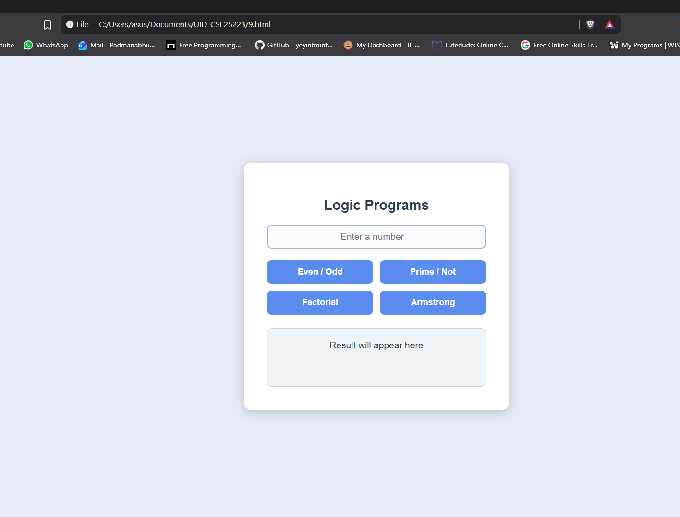
Explanation of the tags:
- <html> – Top-level container for the entire HTML page.
- <head> – Holds metadata, title, styles, and scripts.
- <title> – Sets the page title shown in the browser tab.
- <body> – Contains all visible content of the page.
- <div class="container"> – Groups the main UI into a styled card.
- <h2> – Second-level heading for “Logic Programs”.
- <input type="number"> – Text box that accepts only numeric input.
- id="numInput" – Unique name used in JavaScript to access the input.
- onclick="checkEvenOdd()" – Runs the checkEvenOdd function when the button is clicked.

WEEK-10
10.Aim: Write JavaScript conditional statement to find the sign of product of three numbers using functions .Display an alert box with specified sign. Write a java script conditional statements to sort 3 numbers using functions display an alert box to show the result.write a java script conditional statement to find largest of find largest of five numbers using function and onclick event .display an alert box to show the result .write a java script for loop that will iterate from 0 to 15. For each iteration ,it will check if the current number odd or even , and display a message on screen .write a java script program to read 6 subjects marks from the student then computes the average marks of students then, this average is used to determine the corresponding grade.
Code:
<!DOCTYPE html>
<html>
<head>
<title>Logic Programs</title>
<style>
body {
font-family: Arial;
display: flex;
height: 100vh;
background: #edf2f7;
}
.left {
width: 30%;
background: #dbeafe;
padding: 20px;
border-right: 3px solid #93c5fd;
}
.right {
width: 70%;
background: #f8fafc;
padding: 20px;
}
input {
width: 95%;
padding: 10px;
margin-bottom: 10px;
background: #ffffff;
border: 1px solid #cbd5e1;
color: #1f2937;
}
button {
width: 100%;
padding: 10px;
margin-bottom: 10px;
background: #2563eb;
border: none;
cursor: pointer;
color: white;
}
#output {
background: #eff6ff;
padding: 20px;
min-height: 200px;
white-space: pre-line;
color: #111827;
}
</style>
</head>
<body>
<div class="left">
<h3>Enter Input</h3>
<input type="text" id="numbers" placeholder="Click a button to see input format">
<button onclick="signProduct()">Sign of Product</button>
<button onclick="sortNumbers()">Sort Numbers</button>
<button onclick="largestNumber()">Largest Number</button>
<button onclick="oddEvenLoop()">Odd / Even 0-15</button>
<button onclick="studentGrade()">Student Grade</button>
</div>
<div class="right">
<h3>Output</h3>
<div id="output">Result will appear here</div>
</div>
<script>
function getNumbers() {
let input = document.getElementById("numbers").value;
return input.split(",").map(Number);
}
function signProduct() {
let input = document.getElementById("numbers").value;
if (input === "") {
document.getElementById("output").textContent =
"Enter 3 numbers like: 0,-1,4";
return;
}
let nums = getNumbers();
let negative = 0;
for (let n of nums) {
if (n < 0) negative++;
}
let result = (negative % 2 == 0) ? "+1" : "-1";
alert(result);
document.getElementById("output").textContent = "Sign: " + result;
}
function sortNumbers() {
let input = document.getElementById("numbers").value;
if (input === "") {
document.getElementById("output").textContent =
"Enter 3 numbers like: 0,-1,4";
return;
}
let nums = getNumbers();
nums.sort((a, b) => b - a);
alert(nums.join(", "));
document.getElementById("output").textContent =
"Sorted: " + nums.join(", ");
}
function largestNumber() {
let input = document.getElementById("numbers").value;
if (input === "") {
document.getElementById("output").textContent =
"Enter 5 numbers like: -5,-2,-6,0,-1";
return;
}
let nums = getNumbers();
let max = nums[0];
for (let n of nums) {
if (n > max) max = n;
}
alert("Largest: " + max);
document.getElementById("output").textContent =
"Largest: " + max;
}
function oddEvenLoop() {
let input = document.getElementById("numbers").value;
if (input === "") {
document.getElementById("output").textContent =
"Enter a number like: 15 (to check from 0 to that number)";
return;
}
let n = Number(input);
let result = "";
for (let i = 0; i <= n; i++) {
if (i % 2 == 0)
result += i + " is Even\n";
else
result += i + " is Odd\n";
}
document.getElementById("output").textContent = result;
}
function studentGrade() {
let input = document.getElementById("numbers").value;
if (input === "") {
document.getElementById("output").textContent =
"Enter 6 subject marks like: 70,80,90,60,75,85";
return;
}
let nums = getNumbers();
let sum = 0;
for (let n of nums) sum += n;
let avg = sum / nums.length;
let grade;
if (avg >= 90) grade = "A";
else if (avg >= 75) grade = "B";
else if (avg >= 60) grade = "C";
else grade = "D";
alert("Average: " + avg + " Grade: " + grade);
document.getElementById("output").textContent =
"Average: " + avg + " | Grade: " + grade;
}
</script>
</body>
</html>
Output:
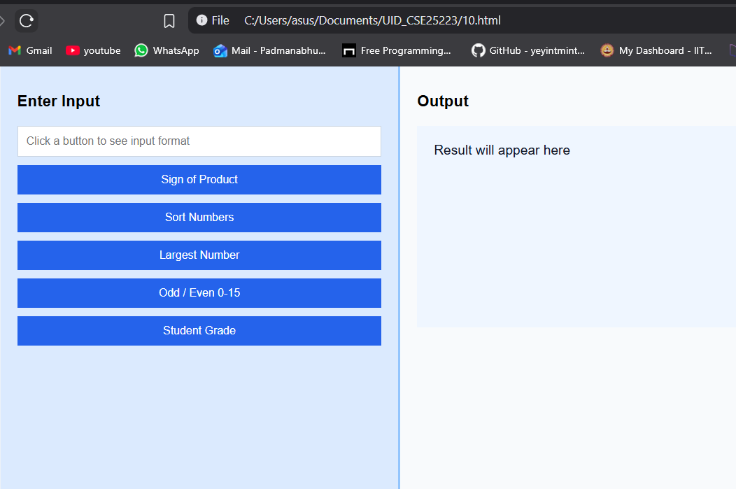
Explanation of the tags:
- getNumbers() – Gets the text from the input box, splits it by commas, and converts each value into a number.
- signProduct() – Checks how many negative numbers are entered and decides whether the product sign is +1 or -1.
- sortNumbers() – Takes the entered numbers and sorts them in descending order using sort((a, b) => b - a).
- largestNumber() – Finds the biggest value by comparing each number one by one in a loop.
- oddEvenLoop() – Prints whether every number from 0 to the entered value is even or odd.
- studentGrade() – Calculates the average of all marks and assigns a grade based on that average.
- document.getElementById("numbers") – Selects the input element with id numbers so JavaScript can read its value.
- input.split(",") – Breaks a comma-separated string into separate parts.
- map(Number) – Converts each split value from text into a numeric value.
- white-space: pre-line; – Keeps line breaks in the output box so each even/odd result appears on a new line.

WEEK-11
11.A.Aim: A website requires users to enter a username. The system should display a message while typing if the username is less than 5 characters.
Code:
<html>
<head>
<title>Username Check</title>
<style>
body {
margin:0;
font-family: Arial;
background: linear-gradient(120deg,#2980b9,#6dd5fa);
display:flex;
justify-content:center;
align-items:center;
height:100vh;
}
.card {
background:white;
padding:30px;
border-radius:12px;
width:300px;
box-shadow:0 10px 25px rgba(0,0,0,0.2);
}
input { width:100%; padding:10px; margin-top:10px; }
</style>
</head>
<body>
<div class="card">
<h2>Username</h2>
<input type="text" id="username" placeholder="Enter username"
onkeyup="checkUsername()">
<p id="msg"></p>
</div>
<script>
function checkUsername() {
let val=document.getElementById("username").value;
let msg=document.getElementById("msg");
if(val.length<5){ msg.innerText="Minimum 5 characters required";
msg.style.color="red"; }
else{ msg.innerText="Valid username"; msg.style.color="green"; }
}
</script>
</body>
</html>
Output:
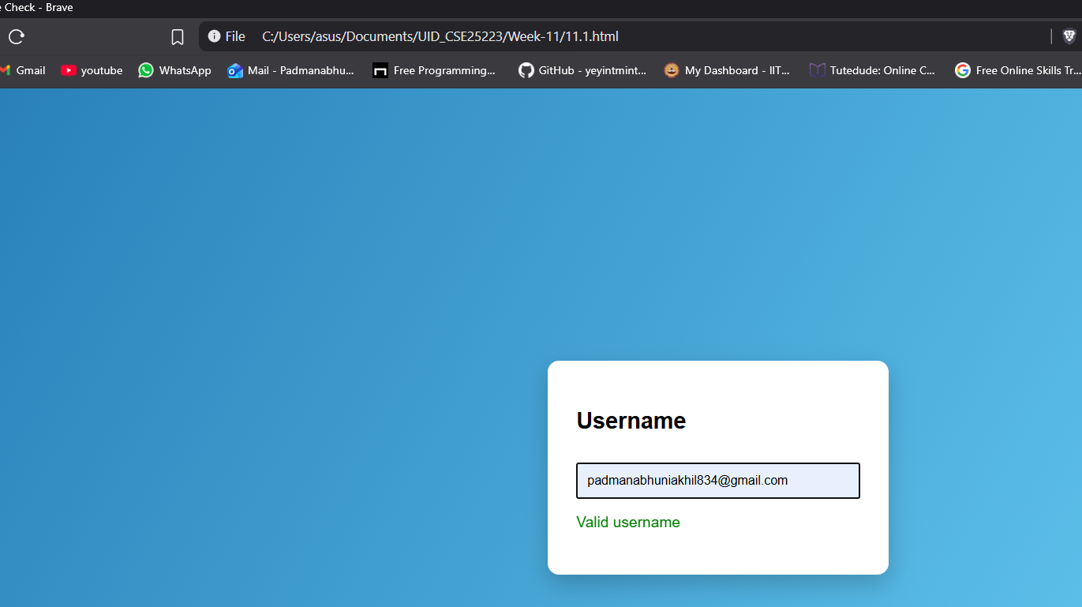
Explanation of the tags:
- function : used to define a block of code that performs username validation
- getElementById() : used to access username input and message element
- .value : used to get value from input box
- length : used to check number of characters entered
- if condition : used to check if username is less than 5 characters
- innerText : used to display message on screen
- style.color : used to change text color based on validation

B.Aim: A registration form should validate email format before submission. If invalid, the form should not be submitted.
Code:
<html>
<head>
<title>Email Validation</title>
<style>
body{margin:0;font-family:Arial;background:linear
gradient(120deg,#ff6a00,#ee0979);display:flex;justify-content:center;align-items:center;height:100vh;}
.card{background:white;padding:30px;border-radius:12px;width:320px;box-shadow:0
10px 25px rgba(0,0,0,0.2);}
input,button{width:100%;padding:10px;margin-top:10px;}
button{background:#ee0979;color:white;border:none;cursor:pointer;}
</style>
</head>
<body>
<div class="card">
<h2>Email Check</h2>
<form onsubmit="return validateEmail()">
<input type="text" id="email" placeholder="Enter Email">
<button type="submit">Submit</button>
</form>
</div>
<script>
function validateEmail(){
let email=document.getElementById("email").value;
let pattern=/^[^ ]+@[^ ]+\.[a-z]{2,3}$/;
if(pattern.test(email)){
alert("Email is valid");
return true;
}else{
alert("Invalid Email");
return false;
}
}
</script>
</body>
</html>
Output:
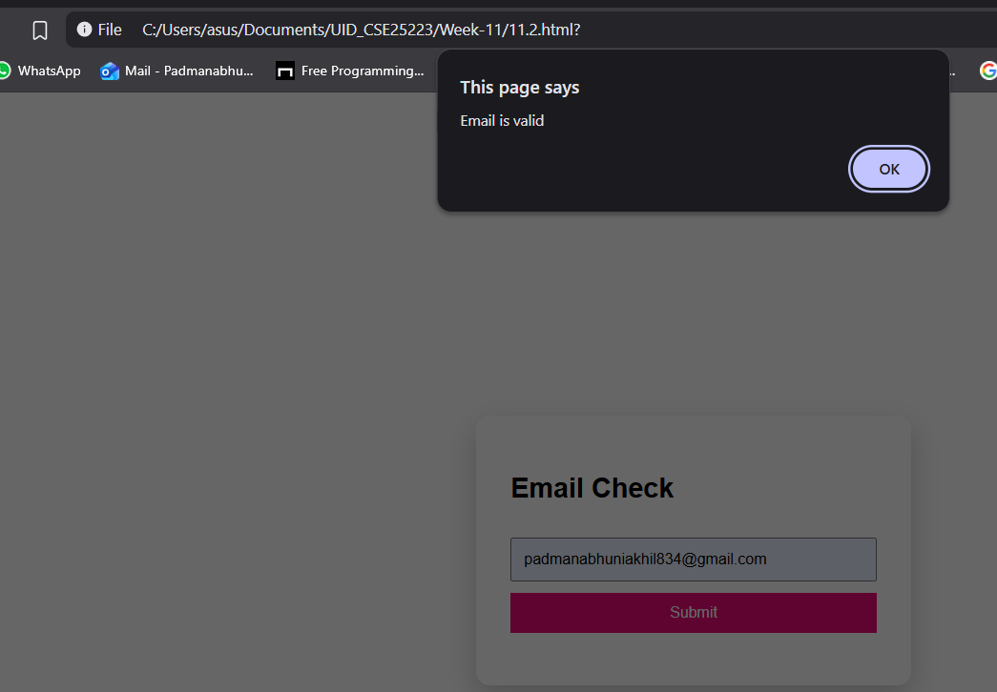
Explanation of the tags:
- .value : gets the email value entered by user
- pattern : regular expression used to check valid email format
- test() : checks if email matches pattern
- if condition : checks whether email is valid or not
- alert() : used to display popup message for valid or invalid email
- return false : prevents form submission if invalid
- return true : allows form submission if valid

C.Aim: A system should check password strength while typing and display whether it is weak or strong.
Code:
<html>
<head>
<title>Password Strength</title>
<style>
body{margin:0;font-family:Arial;background:linear
gradient(120deg,#00b09b,#96c93d);display:flex;justify-content:center;align-items:center;height:100vh;}
.card{background:white;padding:30px;border-radius:12px;width:350px;box-shadow:0
10px 25px rgba(0,0,0,0.2);}
input{width:100%;padding:10px;margin-top:10px;}
</style>
</head>
<body>
<div class="card">
<h2>Password Strength</h2>
<p><b>Rules:</b><br>• At least 6 characters<br>• One uppercase letter<br>• One
special symbol</p>
<input type="password" id="pass" onkeyup="checkStrength()">
<p id="msg"></p>
</div>
<script>
function checkStrength(){
let pass=document.getElementById("pass").value;
let msg=document.getElementById("msg");
let strong=/^(?=.*[A-Z])(?=.*[!@#$%^&*]).{6,}$/;
if(strong.test(pass)){
msg.innerText="Strong Password";
msg.style.color="green";
}else{
msg.innerText="Weak Password";
msg.style.color="red";
}
}
</script>
</body>
</html>
Output:
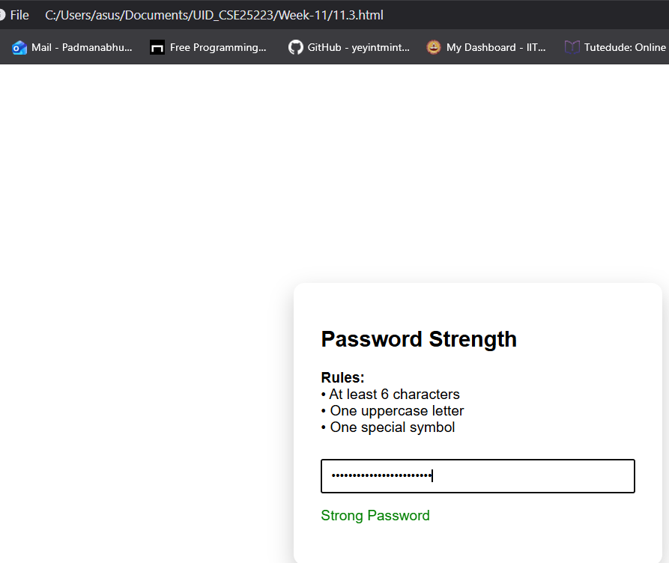
Explanation of the tags:
- pattern : regular expression used to check password strength
- (?=.*[A-Z]) : ensures at least one uppercase letter
- (?=.*[!@#$%^&*]) : ensures at least one special symbol
- .{6,} : ensures minimum 6 characters
- test() : checks if password matches pattern
- if condition : checks strong or weak password
- innerText : displays result message
- style.color : changes text color based on strength
D.Aim: A form should validate a mobile number when the user leaves the input field. The number must be exactly 10 digits.
Code:
<!DOCTYPE html>
<html>
<head>
<title>Mobile Validation</title>
<style>
body{margin:0;font-family:Arial;background:linear
gradient(120deg,#fc466b,#3f5efb);display:flex;justify-content:center;align-items:center;height:100vh;}
.card{background:white;padding:30px;border-radius:12px;width:320px;box-shadow:0
10px 25px rgba(0,0,0,0.2);}
input{width:100%;padding:10px;margin-top:10px;}
</style>
</head>
<body>
<div class="card">
<h2>Mobile & Password</h2>
<input type="text" id="mobile" placeholder="Enter Mobile"
onblur="validateMobile()">
<input type="password" id="pass" placeholder="Enter Password"
onkeyup="checkPass()">
<p id="msg"></p>
</div>
<script>
function validateMobile(){
let num=document.getElementById("mobile").value;
let msg=document.getElementById("msg");
let pattern=/^[0-9]{10}$/; if(pattern.test(num)) msg.innerText="Valid mobile";
else msg.innerText="Invalid mobile";
}
function checkPass(){
let pass=document.getElementById("pass").value;
let strong=/^(?=.*[A-Z])(?=.*[!@#$%^&*]).{6,}$/;
let msg=document.getElementById("msg");
if(strong.test(pass)) msg.innerText="Strong Password";
else msg.innerText="Weak Password";
}
</script>
</body>
</html>
Output:
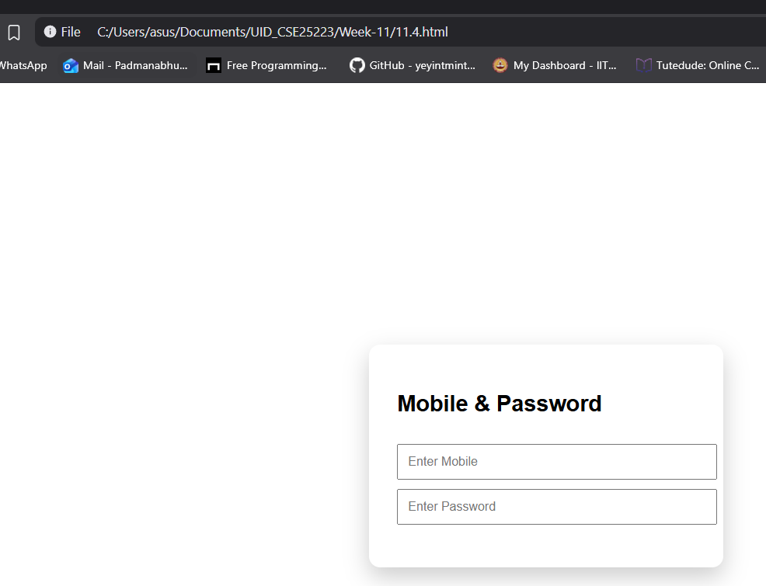
Explanation of the tags:
- onblur : triggers validation when user leaves mobile input field
- onkeyup : triggers password validation while typing
- function : defines validation logic
- getElementById() : used to access input fields and message
- .value : gets input values
- pattern : regular expression for mobile validation
- ^[0-9]{10}$ : ensures exactly 10 digits
- test() : checks if mobile number is valid
- if condition : checks valid or invalid mobile password
- pattern : same as strong password rule
- innerText : displays result message

E.Aim: Design an HTML page, such that the registration form must validate:
- Name (not empty)
- Email (valid format)
- Password (minimum 6 characters)
Code:
<html>
<head>
<title>Register</title>
<style>
body{margin:0;font-family:Arial;background:linear
gradient(120deg,#141e30,#243b55);display:flex;justify-content:center;align-items:center;height:100vh;color:white;}
.card{background:white;color:black;padding:30px;border-radius:12px;width:350px;box-shadow:0 10px 25px rgba(0,0,0,0.3);}
input,button{width:100%;padding:10px;margin-top:10px;}
button{background:#243b55;color:white;border:none;cursor:pointer;}
</style>
</head>
<body>
<div class="card">
<h2>Registration Form</h2>
<form onsubmit="return validateForm()">
<input type="text" id="name" placeholder="Name">
<input type="text" id="email" placeholder="Email">
<input type="password" id="pass" placeholder="Password">
<button type="submit">Register</button>
<p id="msg"></p>
</form>
</div>
<script>
function validateForm(){
let name=document.getElementById("name").value;
let email=document.getElementById("email").value;
let pass=document.getElementById("pass").value;
let msg=document.getElementById("msg");
let emailPattern=/^[^ ]+@[^ ]+\.[a-z]{2,3}$/;
let strong=/^(?=.*[A-Z])(?=.*[!@#$%^&*]).{6,}$/;
if(name===""){ msg.innerText="Name required"; return false; }
if(!emailPattern.test(email)){ msg.innerText="Invalid email"; return false; }
if(!strong.test(pass)){ msg.innerText="Weak password"; return false; }
alert("Registration Successful");
return true;
}
</script>
</body>
</html>
Output:
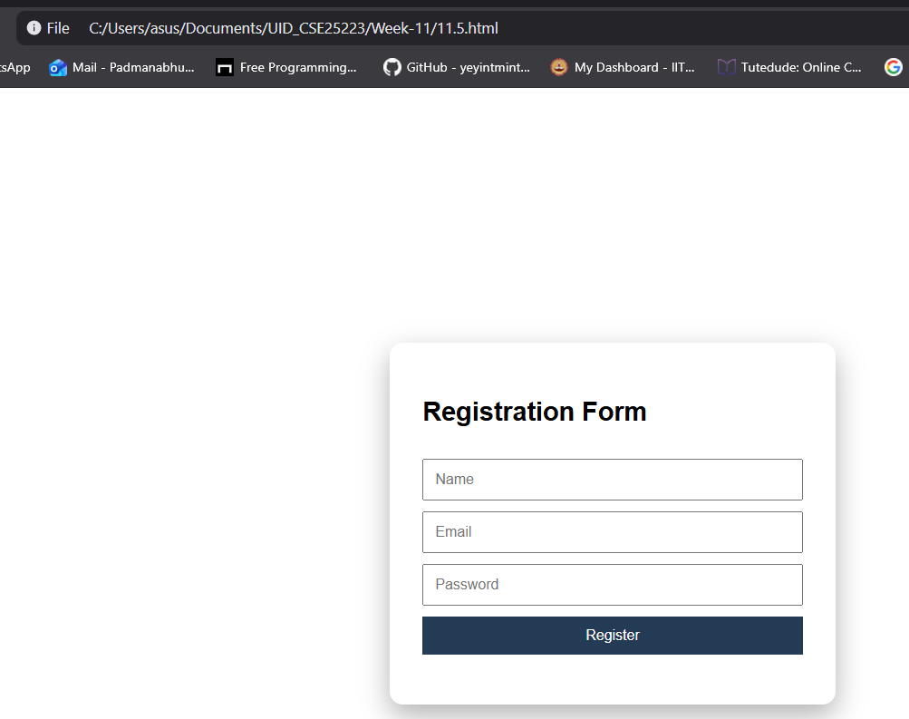

Explanation of the tags:
- body : centers form with gradient background
- .card : used to create form container
- form : used to collect user data
- input : used to take name email and password
- button : used to submit form
- onsubmit : triggers validation before submission
- function : defines form validation process
- getElementById() : used to access form fields
- .value : gets input values email
- Pattern : checks valid email format
- strong pattern : checks password strength
- alert() : shows success message when all validations pass
- return false : prevents submission if invalid
- return true : allows submission if valid
- innerText : displays error messages

